Sales and Distribution (SD)
This case study explains an integrated sales and distribution process in detail and thus fosters a thorough understanding of each process step and underlying SAP functionality.

Product  S/4HANA 2020  Global Bike  Fiori 3.0  Level  Beginner  Focus  Sales and Distribution  Authors  Bret Wagner  Stefan Weidner  Version  4.1  Last Update  June 2022 | MOTIVATION  The data entry of the exercises for sales was reduced because much of the data already existed in the SAP system. The stored data, known as master data, simplifies the handling of business processes.  In the sales order process, you used master data that already existed in the system, such as customers, material (products that Global Bike sells) and conditions, to shorten the sales process.  In this case study you will create your own master data, e.g. a new customer. |  | PREREQUISITES  Before you use this case study, you should be familiar with navigation in the SAP system.  In order to successfully work through this case study, it is not necessary to have finished the SD exercises. However, it is recommended.  NOTES  This case study uses the model company Global Bike.  

 | Process Overview
Learning Objective Understand and perform an integrated order-to-cash cycle.  Scenario In order to process a complete order-to-cash process you will take on different roles within the Global Bike company, e.g. sales agent, warehouse worker, accounting clerk. Overall, you will be working in the Sales and Distribution (SD), the Materials Management (MM) and the Financial Accounting (FI) departments.  Employees involved David Lopez (Sales Representative US East)  Maria Diaz (Sales Person 1 US East)  Matthias Dosch (Sales Person 2 US East)  Sandeep Das (Warehouse Supervisor)  Sergey Petrov (Warehouse Employee)  Stephanie Bernard (AR Accountant) |  | Time 120 min
You start the sales order process by creating a new business partner (BP) – called the The Bike Zone – in Orlando with the role “Customer”. Then, you receive an inquiry which you will process into a quotation. Once the quotation is accepted by the customer you create a sales order referencing the quotation. As you will have enough bikes in stock, you deliver the products sold to your customer, create an invoice and receive the payment. The graphic below displays the complete process.

Table of Contents
Process Overview 2
Step 1: Create New Customer 4
Step 2: Create Contact Person for Customer 11
Step 3: Create BP Relationship 13
Step 4: Create customer request 15
Step 5: Create Customer Quotation 20
Step 6: Create Sales Order Referencing a Quotation 24
Step 7: Check Stock Status 26
Step 8: Track Sales Order 28
Step 9: Start Delivery Process 32
Step 10: Track Sales Order 34
Step 11: Pick Materials and Post Goods Issue 36
Step 12: Check Stock Status 39
Step 13: Create billing document for Customer 41
Step 14: Display Billing Document and Post Customer Invoice 43
Step 15: Post Receipt of Customer Payment 44
Step 16: Review Document Flow 47
SD Challenge 51

 | Step 1: Create New Customer
Task Create a new customer.  Short Description Use the SAP Fiori Launchpad to create a new customer.  Name (Position) David Lopez (Sales Representative US East) |  | Time 15 min
In this case study, we will create the master data for a new customer. Two types of customer data are stored about a customer – sales data and accounting data. The customer master data is created in three groups, or views – general, accounting, and sales. Customers can be created centrally, meaning that all views are generated concurrently, or responsibility can be distributed so that different personnel in the accounting and sales areas are responsible for creating and maintaining the data in their respective views.  For this task, central creation will be used to enter all of the needed data to define a new customer. |  | Scenario
In the space Sales and Distribution in the section Sales Representative use the app Manage Business Partner Master Data to create a new customer. |  | Manage Business Partner Master Data
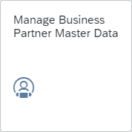
On the Manage Business Partner screen, select the button . A submenu will open. Click Organization here. |  | Organization
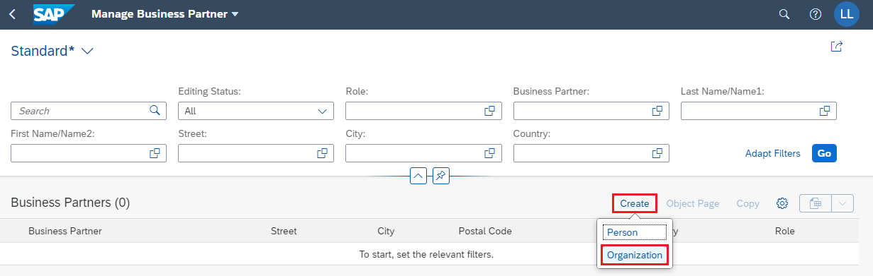
Note The business partner is created superordinate and assigned roles (for example customer, vendor). The different roles are created at specific organizational levels (company code, sales area). Business partners can be categorized as a person, group, or organization, as follows:
- An organization represents entities such as a company (e.g. a legal entity), parts of a legal entity (e.g. a department) or an association. "Organization" is a generic term to represent any situation that may occur in daily business activities.
- A group represents a shared living arrangement, a married couple, or an executive board.
On the Create Organization screen, in the field BP Role click the input help icon . In the pop-up that opens, search for Customer and then select the entry FLCU00 | FI Customer. |  | Customer  FLCU00 | FI Customer
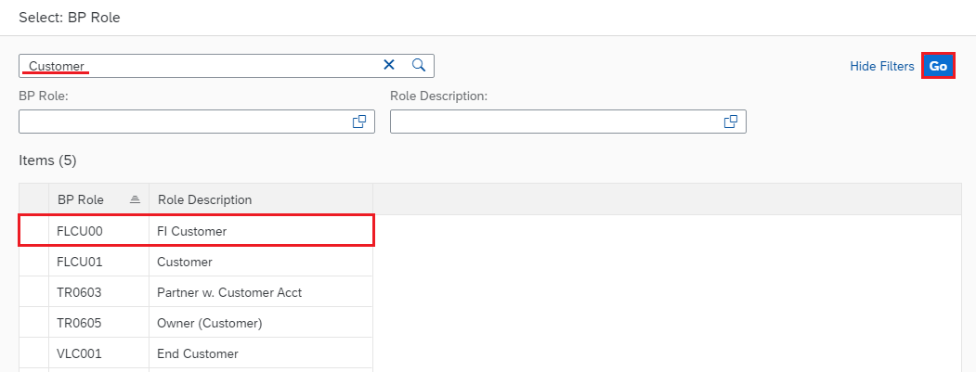
Back on the Create Organization screen, please add the following information. As Organization Title choose Company, and as Name 1 enter The Bike Zone ###. Remember to replace your three-digit number for ###, e.g. if your number is 003, please enter 003. Further, as Street enter 2144 N Orange Ave, and as City enter Orlando (with the Postal Code 32804). In the field Country, please enter US, and choose FL as Region. Finally, for Language select English. Confirm your entries with . |  | Company  The Bike Zone ###  2144 N Orange Ave  Orlando  32804  US  FL  EN
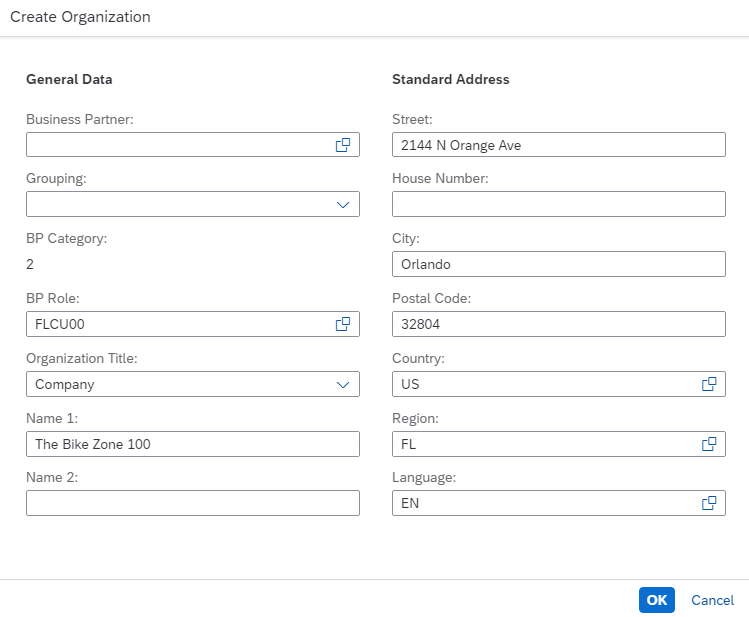
A new overview is generated. Make sure that you have selected the Basic Data tab. In the General Information area, in the field Search Term 1 add your three-digit number ###. |  | Basic Data  ###
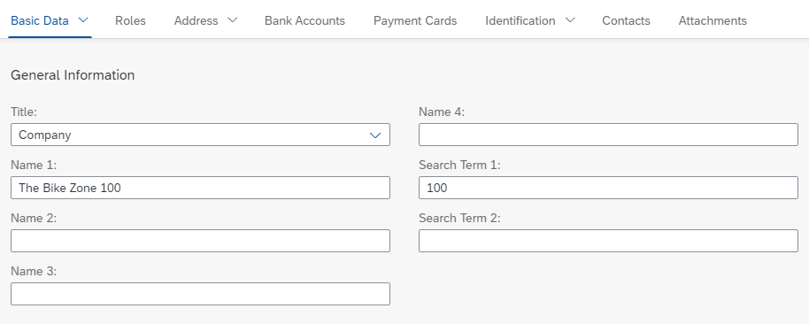
Then, select the Roles tab. Auto-scroll will take you to the correct position. You will see a line with the details of the business partner role as well as the validity dates. At the end of the line, click to maintain further details. |  | Roles
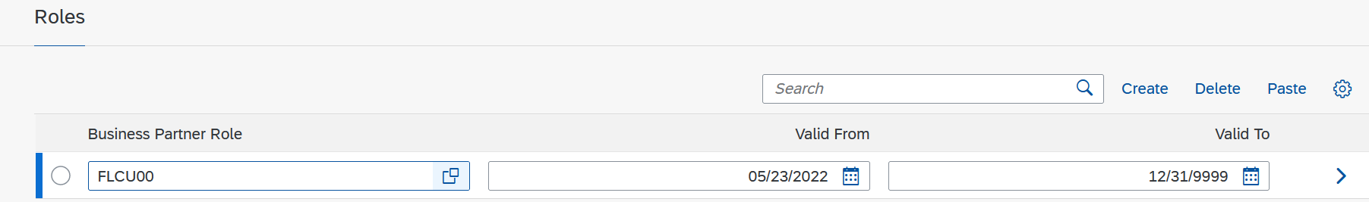
A new screen is loading. Select the Company Codes tab. Currently, there is no record maintained for the company codes, so please select . |  | Company Codes
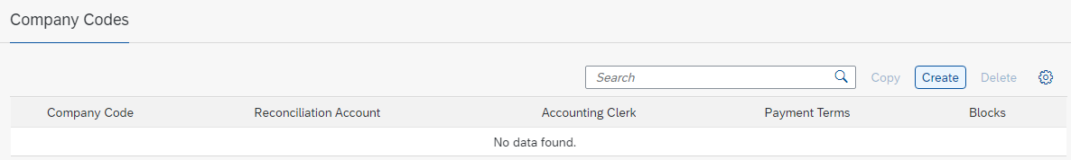
In the Company Code field, click the input help icon . The following pop-up window opens.
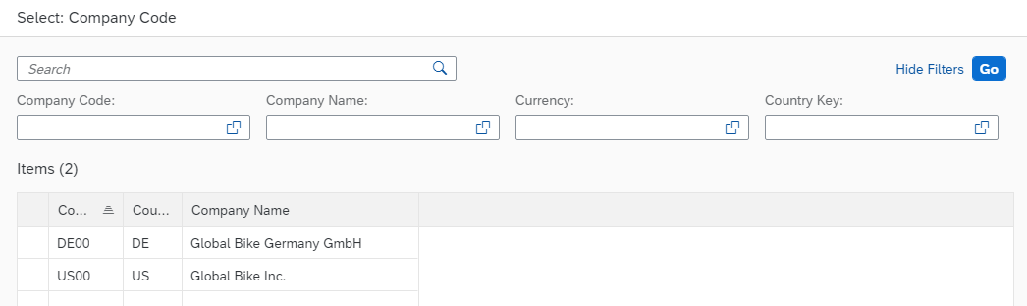
Click on US00 (Global Bike Inc.). In the Finance area, as the Reconciliation Account enter 1200000 (Trade Receivables) and as the Sort Key choose 001 (Posting Date). In the field Payment Term, please add 0001 (Payable immediately Due net). |  | US00  1200000  001  0001
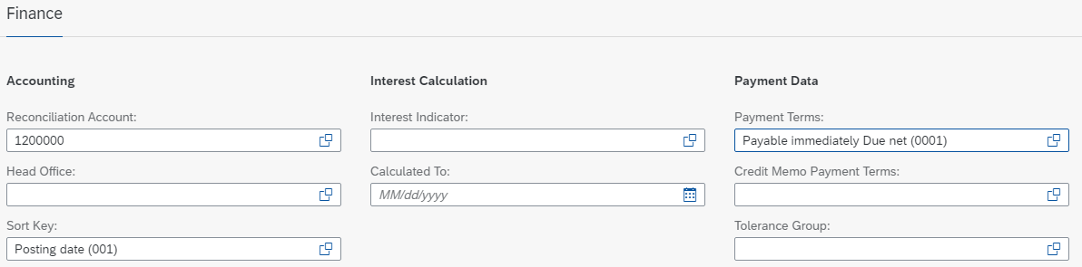
Select to save the draft. You can save the customer role by clicking once again afterwards.
Select the Address Address Details tab. You will see one line with the country details as well as the validity dates. Click to maintain more details. |  | Address  Address Details
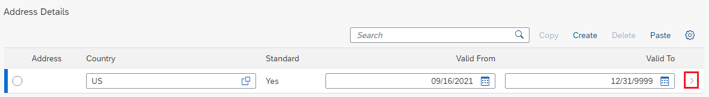
In the Address area, you can use the button to display all the fields. Please find the Transportation Zone field and click the input help icon . The following pop-up window will open. |  | Transportation Zone
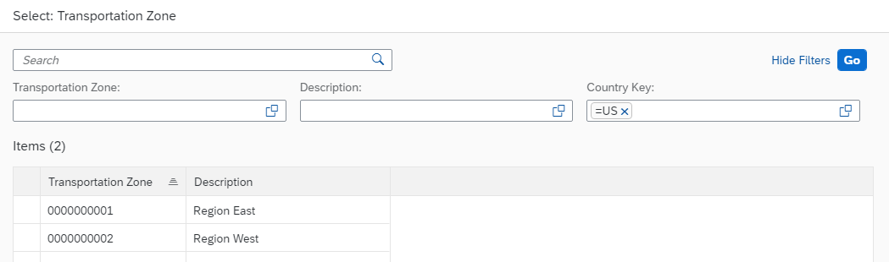
Click on Region East to select it. Finally, use the button again to save your draft. |  | Region East
Note In the general role of the business partner, the name and address of the business partner are documented. The general role data is relevant for sales and for accounting. To avoid data redundancy, they are stored on a client-specific basis. They apply to all organizational units of a client.
To be able to add sales area data for the customer you have just created, you have to assign a new business partner role. For this purpose, select the Roles tab. There, choose again to create a new row for another Business Partner Role. |  | Roles
In the empty Business Partner Role field, click on the value help icon . In the pop-up, search for Customer and then select the entry FLCU01 - Customer. |  | Customer  FLCU01 | Customer
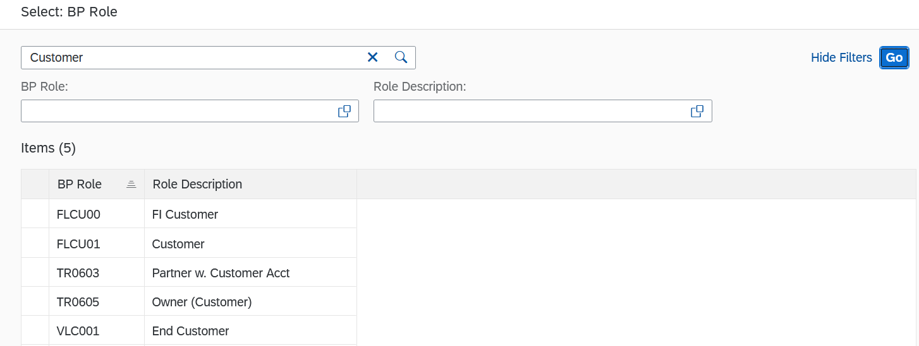
At the end of the new line, you can click on to maintain more details. Switch to the tab Sales Areas to maintain the sales area data of your customer. Since no data record currently exists, select the button accordingly. |  | Sales Areas
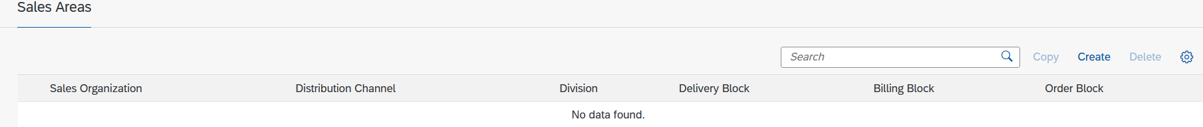
In the field Sales organization click on the value help symbol . In the pop-up window that opens, enter UE00 as the sales organization, WH (Wholesale) as the distribution channel and BI (Bicycles) as the division. Then press 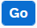. |  | UE00  WH  BI
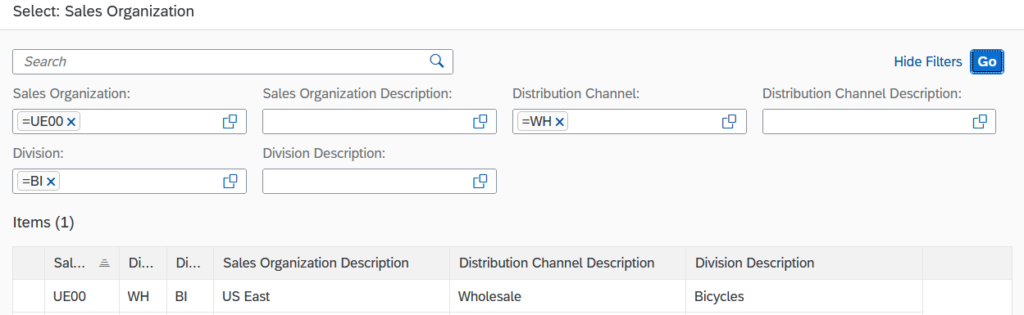
Click on US East to accept the entry. The fields will be filled accordingly in the General Data. |  | US East
Then select the Sales Area Details tab. In the Sales Orders section, enter US0001 as the Sales District and ensure that USD is entered as the currency. |  | Sales Area Details  US0001  USD
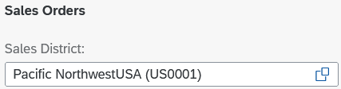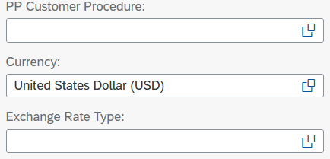
In the Billing section, enter FOB (Free on Board) as the Incoterms and Miami as the Incoterms Location 1. Also add 0001 (Payable immediately Due net) as Payment Terms. |  | FOB  Miami  0001
Incoterms (abbreviation for International Commercial Terms) are internationally recognised terms of delivery published by the International Chamber of Commerce (ICC) for international trade law. |  | Incoterms
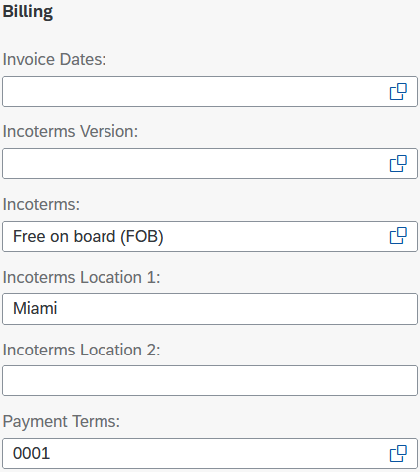
In the Shipping area, select Normal item from the drop-down list as the Delivery Priority and Standard as the Shipping Conditions. Add MI00 (Miami) as the delivery plant. |  | Normal items  Standard  MI00
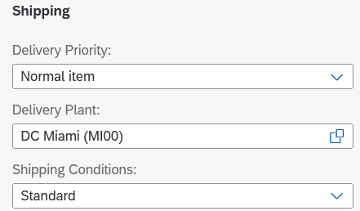
In the Accounting area, select Domestic Revenue as the account assignment group from the drop-down list. In the following area Partial Deliveries use the dropdown list in the field Partial delivery per item and thus select Partial delivery allowed. In the last area of this input screen, Price Group, use the drop-down list to select Bulk Buyer as the Price Group and enter 1 (standard) as the Customer Pricing Procedure. Compare your entries with the following screenshots and confirm your entries with Enter. |  | Domestic Revenue  Partial delivery allowed  Bulk Buyer  1
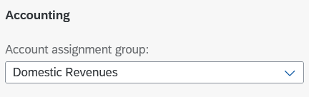
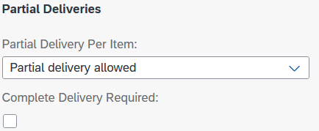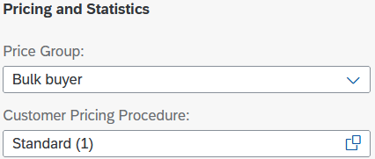
Then select the Taxes tab. Enter the tax classification 0 (no tax) for all three tax categories. |  | Taxes  0
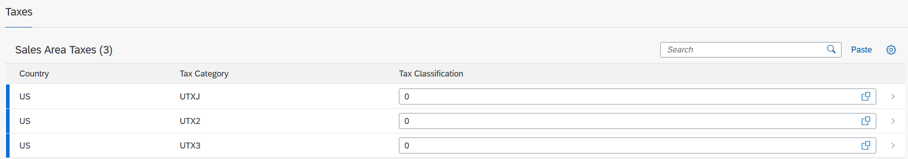
Select the button to save your adjustments as a draft. Then press 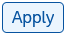to finish editing the client role. To finally save the business partner, press the buitton 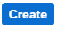 .
The SAP system creates the master data record for the new BP and assigns a unique business partner number. Make a note of the BP number, which you will find in the header.
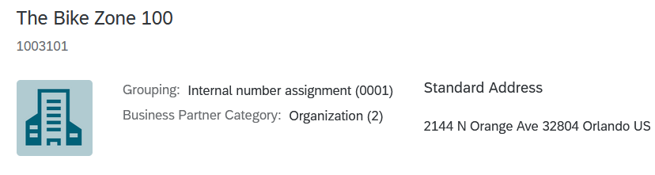 |  | Business Partner Number (Customer)  ___________________
Click on to return to the SAP Fiori Launchpad.

 | Step 2: Create Contact Person for Customer
Task Create a contact person for a customer.  Short Description Use the SAP Fiori Launchpad to create a contact person.  Name (Position) Maria Diaz (Sales Person 1 US East) |  | Time 5 min
As you have created the master data for your new client (The Bike Zone), you can create the master data for a contact person. This contact person is an employee of the client company through whom Global Bike communicates with The Bike Zone. |  | Scenario
In the space Sales and Distribution in the section Sales Representative use the app Manage Business Partner Master Data to create a contact person. |  | Manage Business Partner Master Data
In the Manage Business Partner view, select the item 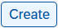. A submenu opens. Click here on Person. |  | Person
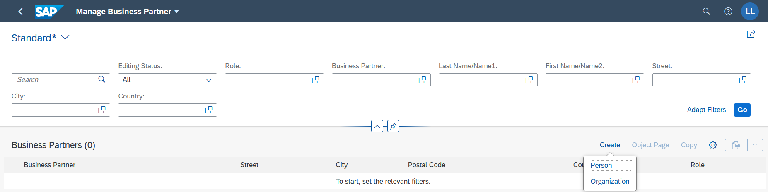
In Create Person, click the value help icon in the BP Role field. In the pop-up, search for Person and then select the entry BUP001 | Contact Person. |  | Person  BUP001 | Contact Person
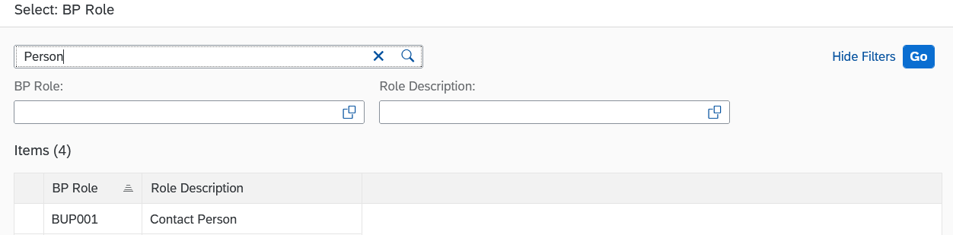
Enter the Person Title, First Name and Last Name of your choice. Add your number (###) to the fictitious surname. This will make it easier for you to identify your entry later if persons with the same name have been created. Please enter US as the Country and EN as the Language. Confirm your entries with . |  | Person Title  First Name  Last Name ###  US  EN
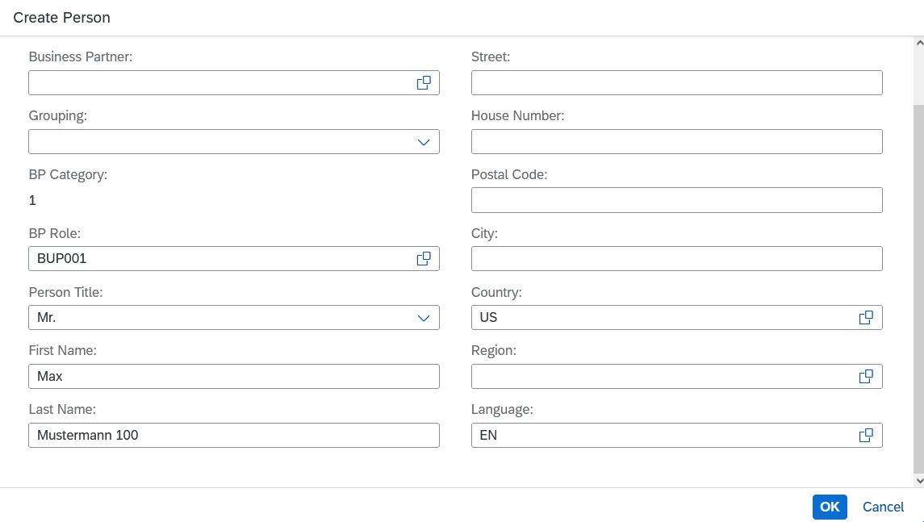
A new overview is generated. In the General Information section, add your three-digit number ### again in the Search Term 1 field. |  | ###
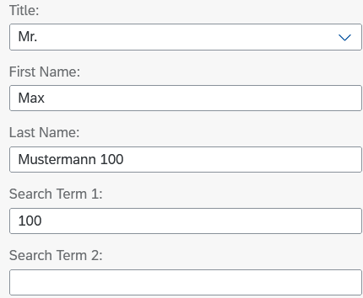
Click on to save your business partner. The SAP system creates the master data record for the new contact person and assigns a unique business partner number (header). Please make a note of this number.
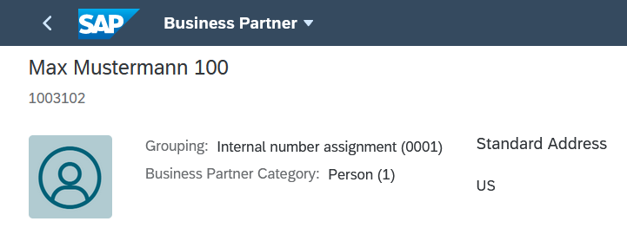 |  | BP Number (Contact Person)  ___________________
Click on to return to the SAP Fiori launchpad.

 | Step 3: Create BP Relationship
Task Create a BP relationship.  Short Description Use the SAP Fiori Launchpad to maintain a Business Partner relationship.  Name (Position) Maria Diaz (Sales Person 1 US East) |  | Time 5 min
The contact person created for The Bike Zone needs to be assigned as a business partner within the customer master. |  | Scenario
In the space Sales Area in the section Sales Person use the Manage Business Partner Master Data app again to customise a business partner, |  | Manage Business Partner Master Data
In the Manage Business Partner Master Data view, enter your Business Partner Number (of Step 1) in the Business Partner field. Alternatively, you can enter Orlando as the Location and *### as the Last Name/Name 1. |  | Business Partner Number (Customer)  (Orlando)  (*###)
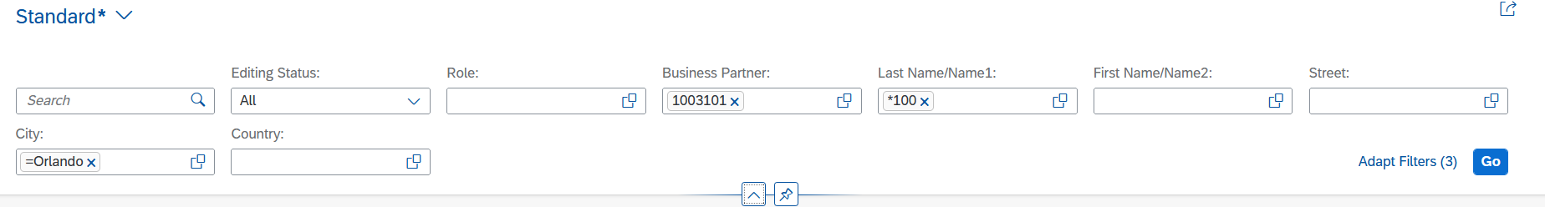
Then press the button 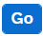. Your business partner should be displayed accordingly.
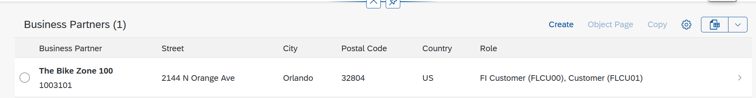
Click on your Business Partner to display the Master Data record. Then press 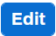 in the upper area. The editing mode opens.
Select the Contacts tab. Click on 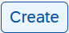 to create a new row in the Contacts section. |  | Contacts
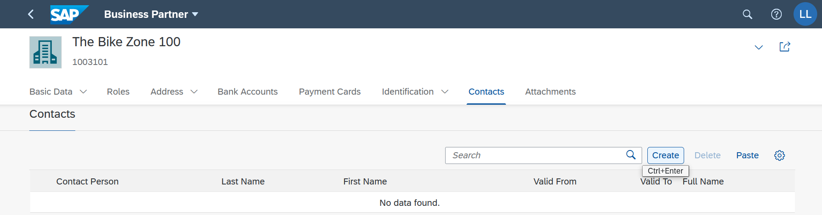
In the Contact Person field, click on the value help icon . In the pop-up window that opens, enter the Business Partner Number of your contact person in the Business Partner field. Alternatively, you can also use the First Name and Name. Then press the button . |  | BP Number (Contact Person)  (First Name)  (Last Name)
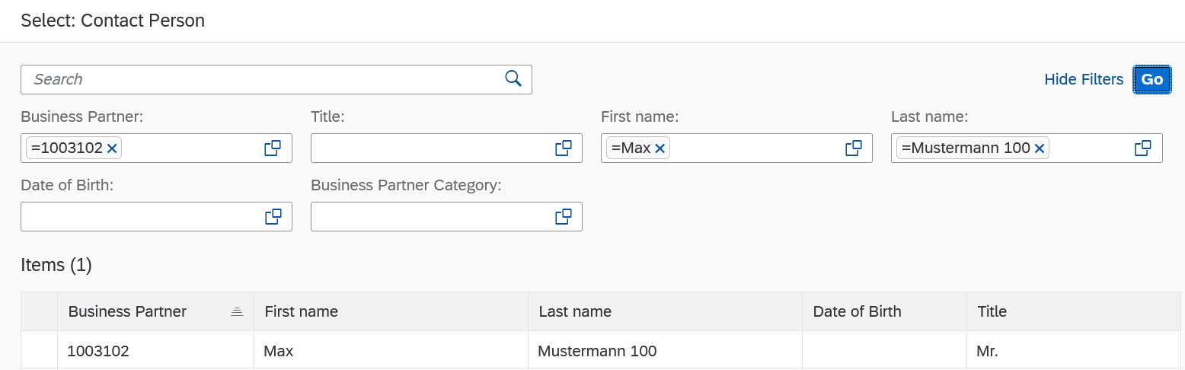
Your business partner is displayed accordingly. Select it with one click to enter it as contact person for your customer (The Bike Zone). Click on 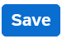 to apply your changes to the business partner.
Click on to return to the SAP Fiori Launchpad.

 | Step 4: Create customer request
Task Create a customer inquiry.  Short Description Use the SAP Fiori Launchpad to create a customer inquiry.  Name (Position) Matthias Dosch (Sales Person 2 US East) |  | Time 10 min
Now, we will enter an inquiry from our new customer, The Bike Zone. An inquiry is a customer’s request to be provided with a quotation or sales information without obligation. An inquiry can relate to materials or services, conditions, and if necessary delivery dates. |  | Scenario  Inquiry
In the space Sales Area in the section Sales Person, use the Manage Sales Inquiries app to create an inquiry. |  | Manage Sales Inquiries
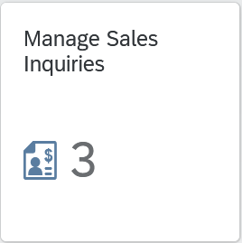
Note This dynamic Fiori app displays 3. This means that Global Bike currently has 3 different customer requests. The number you see depends on the number of requests that you and the other participants have created before. You will encounter this functionality in other apps as well.
If you want to display all existing sales inquiries, press . A list with all inquiries is displayed. If, on the other hand, you want to enter a new sale inquiry, click on 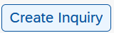.
Enter the abbreviation IN (Inquiry) as the Inquiry Type and UE00 (US East) as the Sales Organization. Also add WH (Wholesale) to the Distribution Channel field and BI (Bicycles) to the Division. |  | IN  UE00  WH  BI
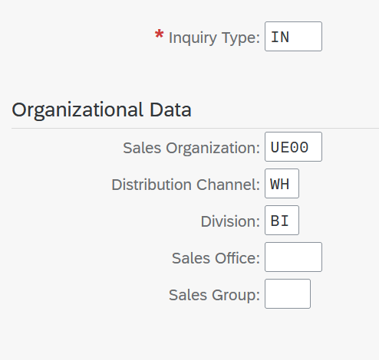
Compare your entries with the screenshot above. Then select 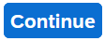, in the lower screen area, to be able to enter further data for the request. This will take you to the following screen.
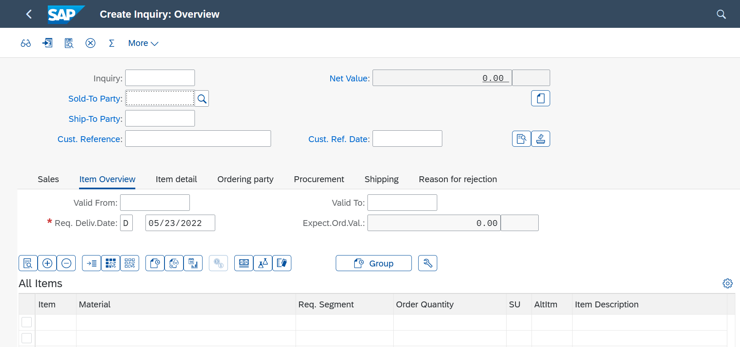
In the Ordering party field, enter the Business Partner Number of your customer The Bike Zone. |  | Business Partner Number (Customer)
Note Alternatively, you can search for your GP number by selecting the input help icon in the Sold-To Party field. As Search Term enter ###, and as Location enter Orlando. Confirm your entry with enter to run the search. Double click on the The Bike Zone line to add the GP to the request. |  | ###  Orlando
Enter ### as the Customer Reference and enter today's date in the fields Customer reference date and Valid from (F4, then Enter). For the Valid until and Requested delivery date fields, enter one month from today. |  | ###  today’s date  today’s date  one month from today  one month from today
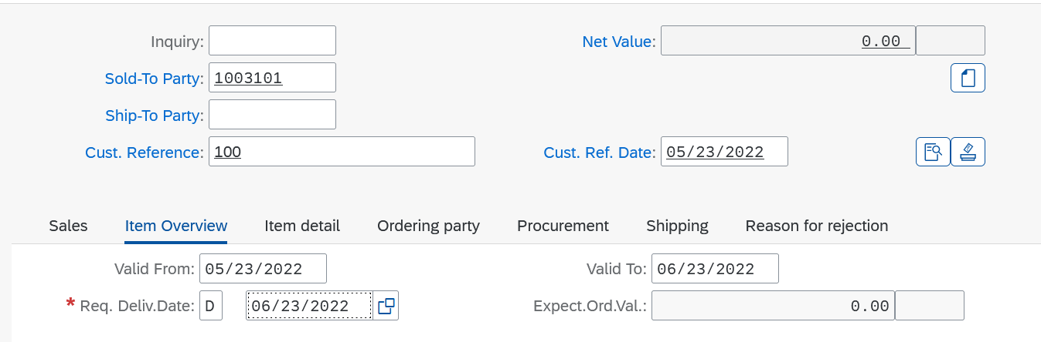
The Bike Zone would like a quote for two products: The Deluxe Touring Bike (black) and the Professional Touring Bike (black). To find these products, use the search function. Click in the Material field and then click on the value help icon .
On the Material by Description Tab, enter *Bike* as the Material Description and *### (e.g. *003 if your number is 003) as the Material. |  | *Bike*  *###
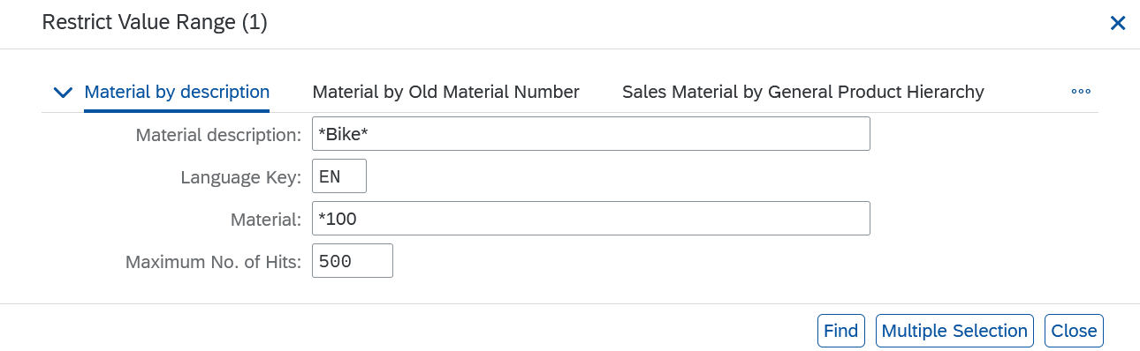
Then click on 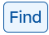 to start the search process. You will get results whose material short text contains "Bike" and whose abbreviation ends in "###".
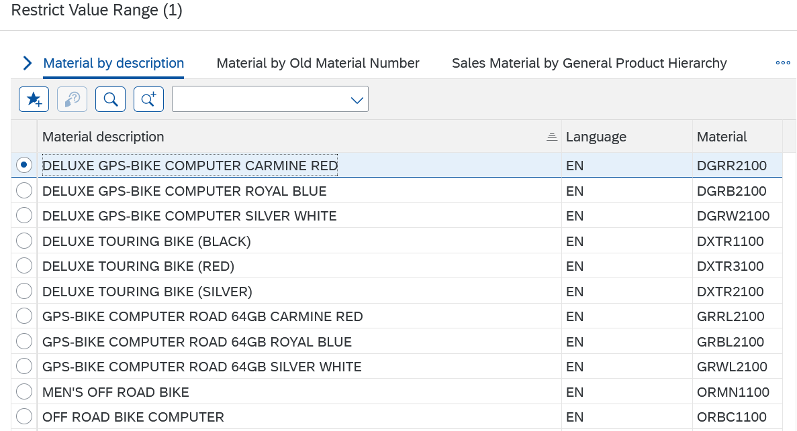
Double click on the Deluxe Touring Bike (Black) to select it. In the following screen, enter an Order Quantity of 5. |  | DXTR1###  5
Repeat the process for the second item, searching for Professional Touring Bike (Black) as the Material and entering an Order Quantity of 2. Select Enter to determine the price for this request. Confirm the message that appears. |  | 2  PRTR1###
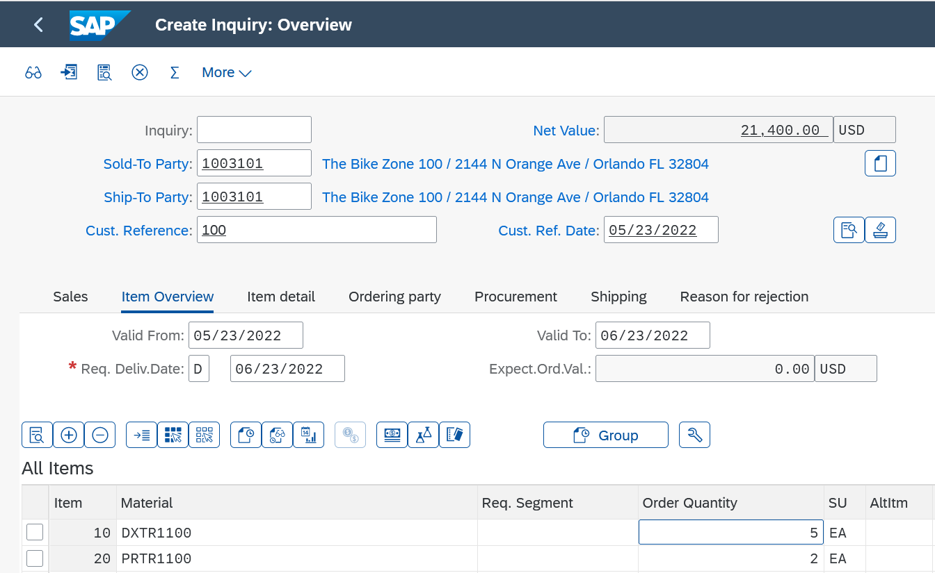
The total price for these 7 bicycles for The Bike Zone is 21,400 USD (net value). The expected order value is a calculated value that multiplies the net value of the order quantity by the probability that a request from this customer will result in an actual order. Select both items and click on .
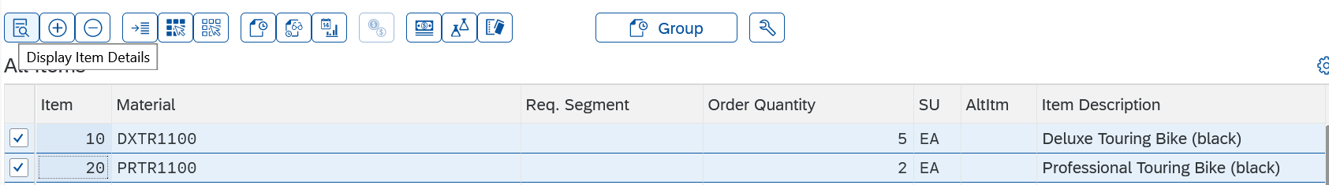
In the lower area of the General Sales Data you will find the field Order Probability. This expresses the percentage probability that an enquiry or quotation item will result in a sales order. Assuming this order probability would be 30%, the expected order value would be 0.30 x 21,400.00 USD = 6,420.00 USD.
Changing the order probabilities may make sense because different requests from customers have different probabilities. Change the Order Probability for the material DXTR### to 70%. Then click on (Next item) in the upper area to go to material PRTR1###. |  | 70
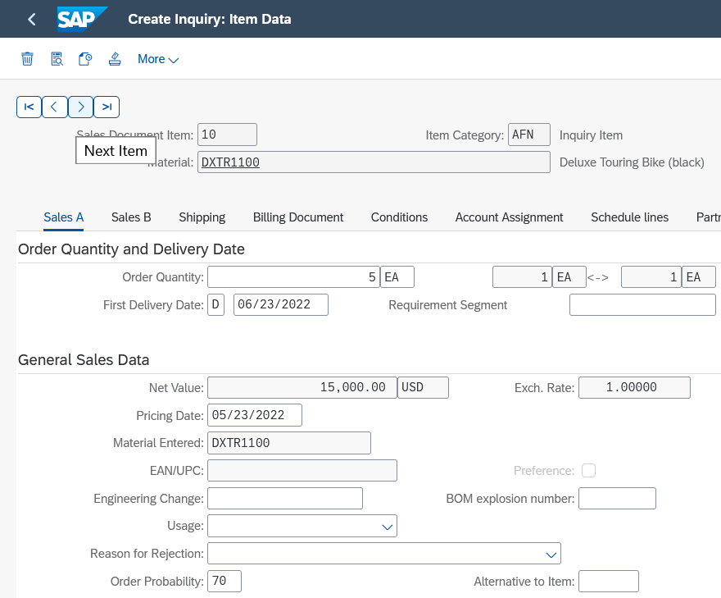
Also enter an Order Probability of 70% there. Confirm your change with Enter. Click on 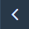 (Back) to update the request and note the new expected order value of 14,980.00 |  | 70
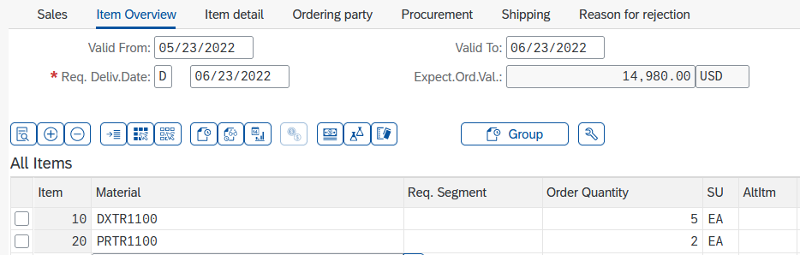
Click on to save the request. The SAP system will assign a unique number to the request. Make a note of it.
Inquiry Number

___________________
Click on to return to the SAP Fiori launchpad.

 | Step 5: Create Customer Quotation
Task Create a customer quotation.  Short Description Use the SAP Fiori Launchpad to create a customer quotation.  Name (Position) David Lopez (Sales Representative US East) |  | Time 10 min
An inquiry presents the terms (price, delivery schedule) to a customer considering a purchase. A quotation is similar, except that it is a legally binding offer for delivering the requested product or services. |  | Quotation
The Bike Zone would like a firm quote for the items in the inquiry created before. We can do this easily by copying the details from the inquiry into the new quotation. To do this, in the space Sales and Distribution and in the section Sales Representative, use the Manage Sales Quotations app. |  | Scenario  Start
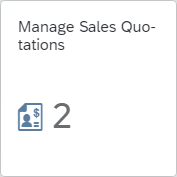
If you want to display all sales quotations, click . A list will be displayed accordingly. On the other hand, if you want to create a new sales quotation, click .
In the Quotation Type field, please enter the code QT (Quotation). In the lower screen area, click . In the Create with Reference pop-up that opens, you can search your inquiry and thus, copy the data into the quotation. For this purpose, make sure that the Inquiry tab is selected. In the Inquiry field, enter your inquiry number. |  | QT  Inquiry  Inquiry Number
Note Alternatively, if you have forgotten your inquiry number, in the Inquiry field click the input help icon . In the Sales document according to customer PO number tab, as Purchase Order No. enter your number (###). |  | ###
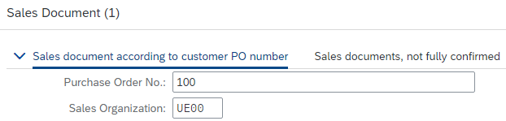
Then click and double-click your order. Your inquiry number will be copied to the Create with Reference window accordingly.
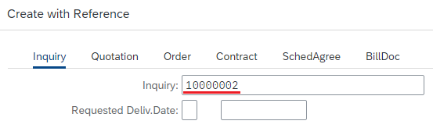
Click to copy the information from the inquiry to the quote screen. This will produce the following screen.
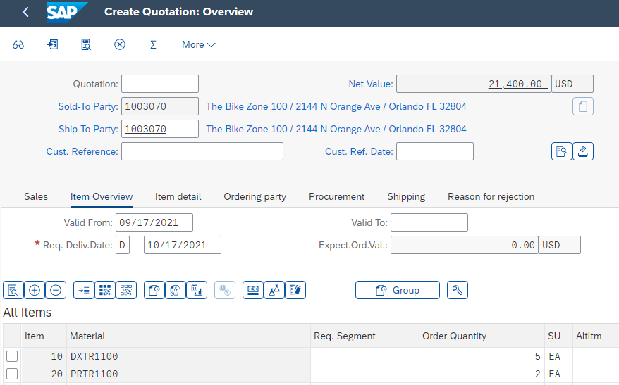
As Cust. Reference enter again ### and as Cust. Ref. Date type in today’s date. In the Valid To field, please add one month from today. Check if the Req. Deliv. Date is set to one month from today. |  | ###  today’s date  one month from today  one month from today
To encourage The Bike Zone to become a loyal customer, you have been authorized to give a $50.00 discount on each Deluxe Touring bike, as well as a 5% discount on the entire order.
To add the $50.00, select the Deluxe Touring bike line in the order, then click on (Item Conditions). You will get a screen that shows the pricing details for your Deluxe Touring Bike.
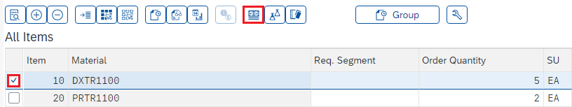
Note The condition master data includes prices, surcharges, and discounts, freights, and taxes. You can define condition master data (condition records) to be dependent on various data. You can, for example, maintain a material price customer-specifically. In SAP, pricing is done using conditions. The pricing procedure defines which condition types are to be used to calculate the final price. Condition type PR00 is a gross price condition.
To add a discount, you can add condition type K004 (material discount) with an amount of 50 to the pricing procedure. |  | K004  50
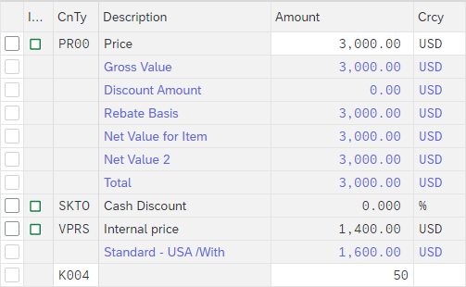
After confirming your entry, a new price for the 5 Deluxe Touring bikes will be calculated.
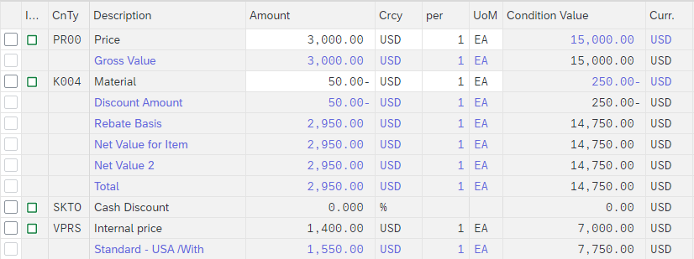
Note that the discount is now applied to the order. Click return to the main quotation screen. To apply a 5% discount to the entire order, follow the pull-down menu path: More ► Goto ► Header ► Conditions
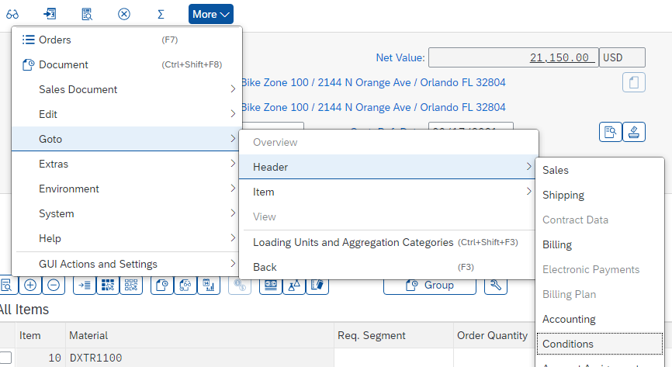
To apply the 5% discount, enter RA00 with an amount of 5. Confirm your entries and note that the price does not yet include the 5% discount. |  | RA00  5
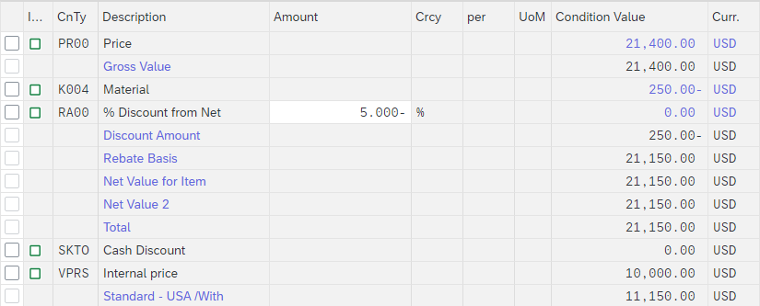
To include the 5% discount, click . The 5% discount is now applied. Note that it is applied to the price after the $50 discount per Deluxe Touring bike.
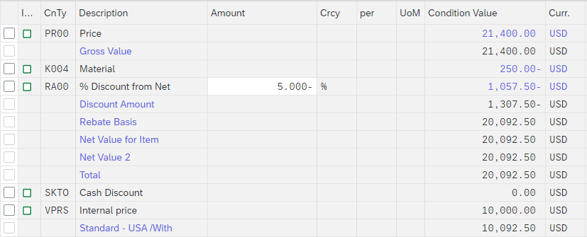
Click on to save the new quotation. The following success message appears. Please write down your quotation number. |  | Quotation Number  ___________________
Click on to return to the SAP Fiori launchpad.

 | Step 6: Create Sales Order Referencing a Quotation
Task Create a sales order with reference to a quotation.  Short Description Use the SAP Fiori Launchpad to create a sales order.  Name (Position) David Lopez (Sales Representative US East) |  | Time 10 min
The Bike Zone has agreed to the terms and conditions in the quotation, and wants to order the bikes in the quotation. As a result, we can simplify the order creation process by copying the quotation into a sales order. |  | Scenario
In the space Sales and Distribution and in the section Sales Representative, you can use the Manage Sales Orders app to create a sales order. |  | Start
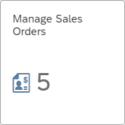
If you want to display all sales orders, click . A list will be displayed accordingly. On the other hand, if you want to create a new sales order, use the button.
On the Create Sales Documents screen, in the Order Type field, please enter the code OR1 (Standard order). In the lower screen area, click on the button. In the Create with Reference pop-up that opens, you can search your quotation and thus, copy the data into the order. For this purpose, make sure that the Quotation tab is selected. In the Quot. field, enter your quotation number. |  | OR1  Quotation  Quotation Number
Note Alternatively, if you have forgotten your quotation number, in the Quot. field click the input help icon . In the Sales document according to customer PO number tab, as Purchase Order No. enter your number (###). |  | ###
Then click and double-click your order. Your quotation number will be copied to the Create with Reference window accordingly.
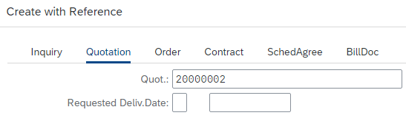
Click to copy the information from the quotation to the sales order screen. Due to the discounts granted in the offer, please note the Net Value has been reduced.
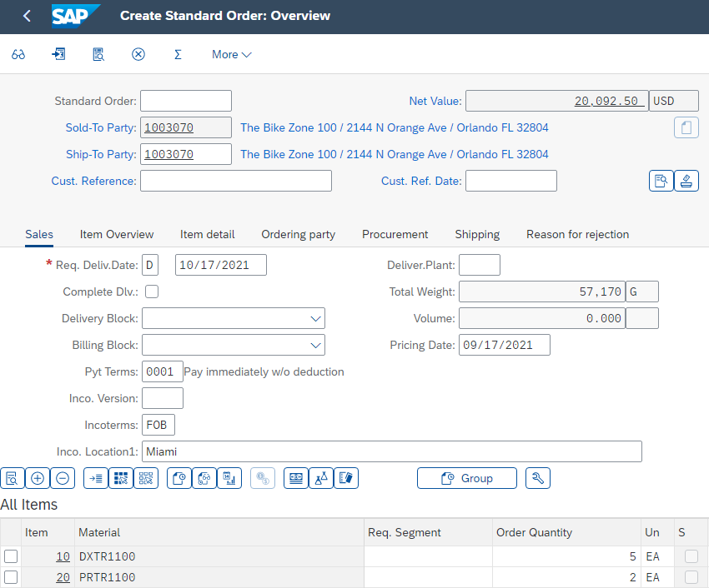
As Customer Reference enter again ### and as Customer Reference Date type in today’s date. Please note that the Requested Delivery Date has been copied from the quotation. Click and write down the number of your sales order. |  | ###  today’s date  Standard Order Number  ___________________
Click on to return to the SAP Fiori launchpad.

 | Step 7: Check Stock Status
Task Check the inventory.  Short Description Use the SAP Fiori Launchpad to check the stock status.  Name (Position) David Lopez (Sales Representative US East) |  | Time 5 min
We can check on the inventory level of the bikes in the sales order for The Bike Zone. For this purpose, in the space Sales and Distribution and in the section Sales Representative, you can use the Stock – Multiple Materials app. |  | Start
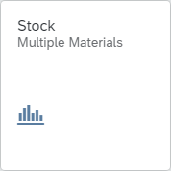
You will see the default screen of the app. Due to the high amount of materials, it is not recommended to search without further restrictions. Therefore, in the Material Number field, please use the input help icon .
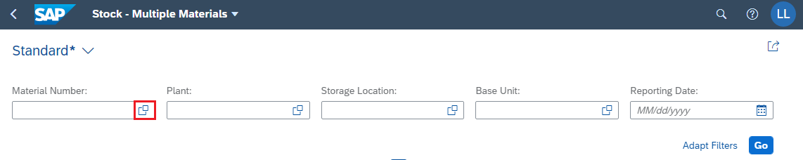
In the pop-up that opens, as Description enter *TOURING* and as Material type in your number (*###). |  | *TOURING*  *###
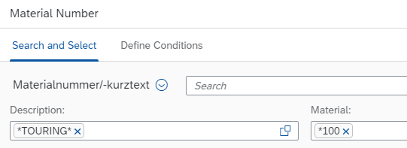
Click to run the search and to generate a result list of all “touring” bikes containing your number “###” in the material code. Select the Deluxe Touring Bike (black) and the Professional Touring Bike (black). To copy your selection to the initial screen, click on the button.
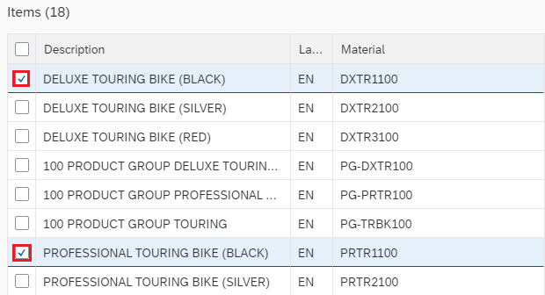
Back in the Stock – Multiple Materials overview, as Plant enter MI00 (Miami) and as Storage Location type in FG00 (Finished Goods). Click to display the corresponding stock levels. |  | MI00  FG00
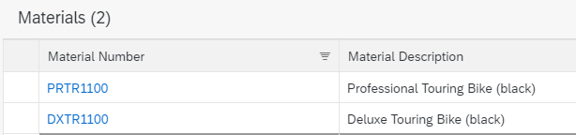
This report shows the stock levels for the plant in Miami. Scroll to the right to see the unrestricted stock.
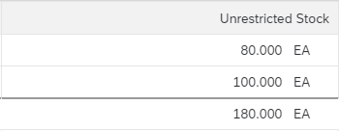
Click on to return to the SAP Fiori launchpad.

 | Step 8: Track Sales Order
Task Track the processing status of the sales order.  Short Description Use the SAP Fiori Launchpad to track a sales order.  Name (Position) David Lopez (Sales Representative US East) |  | Time 5 min
With relatively little user input, the sales order for The Bike Zone has been created. The Track Sales Orders app provides the opportunity to review the order in detail. |  | Scenario
To display and track a sales order, in the space Sales and Distribution and in the section Sales Representative, please use the Track Sales Orders app. |  | Start
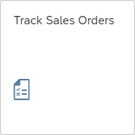
You will see the standard view of the app. In the Search field, enter your number (###) and click to run the search process. |  | ###
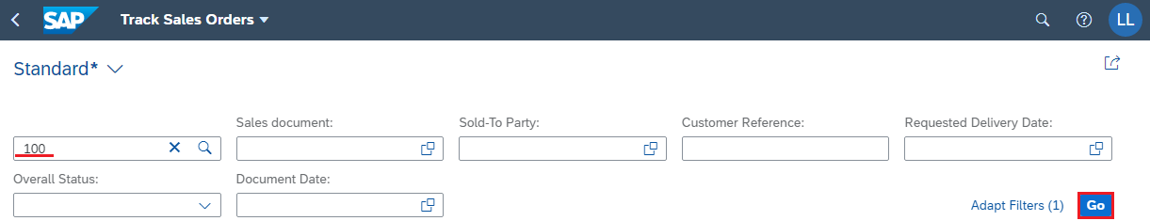
Your order will be displayed in the result list. There you can already see first details like the Overall Fulfillment status or the Net Value.
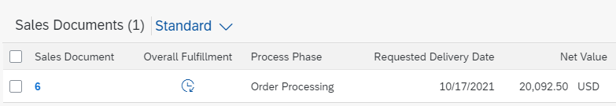
Please click on the line containing your sales order. You will be forwarded to the Track Sales Order Details screen, where you can see all the details of the order.
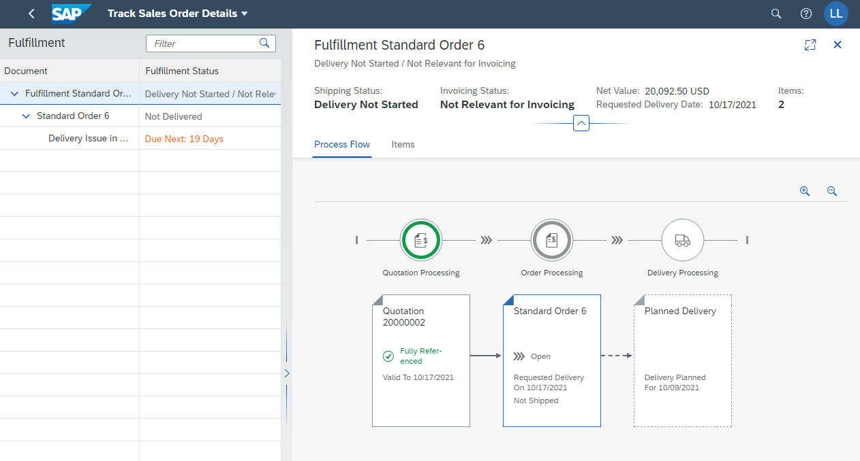
For example, you can see that the quotation processing has been fully processed (“fully referenced”), but that the processing of the standard order is currently still “open”. You can also see the requested delivery date of the order and the planned delivery in the overview.
Afterward, please click on the Items tab. There you will see a list of the ordered bikes and the quantity shipped or already invoiced. |  | Items
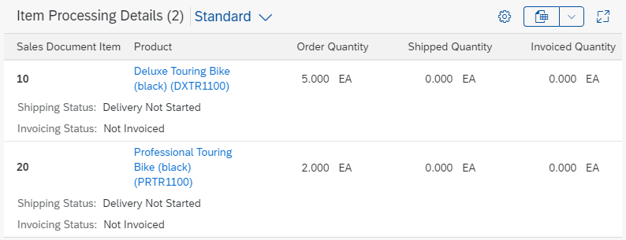
Go back to the Process Flow tab and click on your Standard Order. The following context menu opens. |  | Process Flow
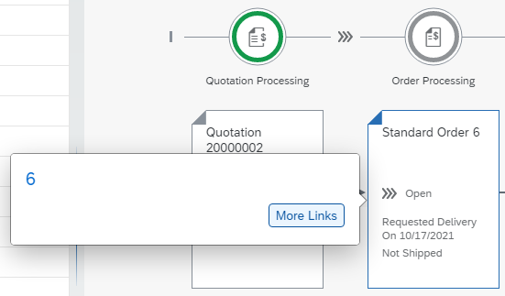
Choose , and in the pop-up that opens, please select the entry Display Sales Order - VA03. You will be forwarded to the corresponding app.
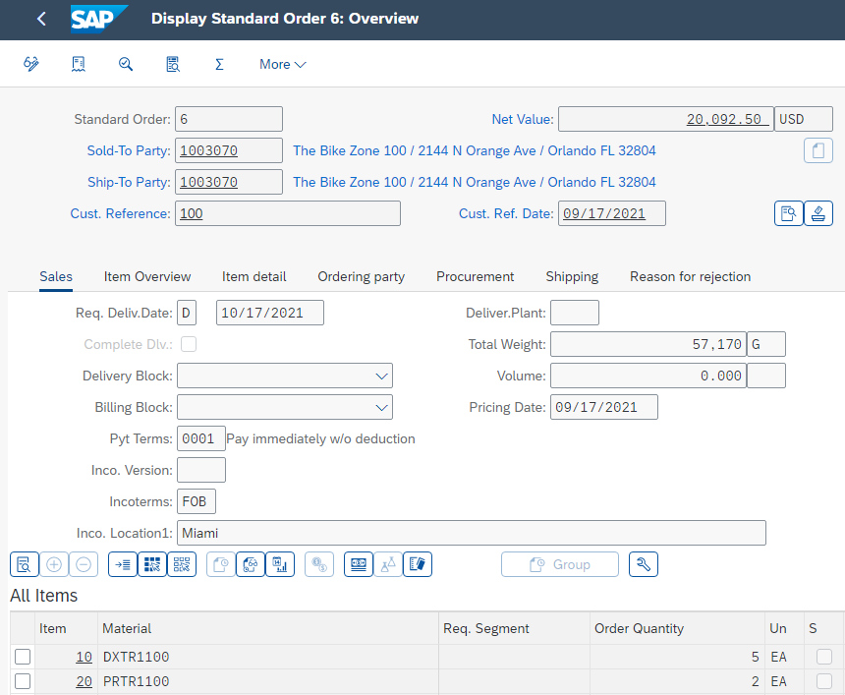
In the All Items section, select the line with the Professional Touring Bike and click (Display Availability) to check availability in detail.
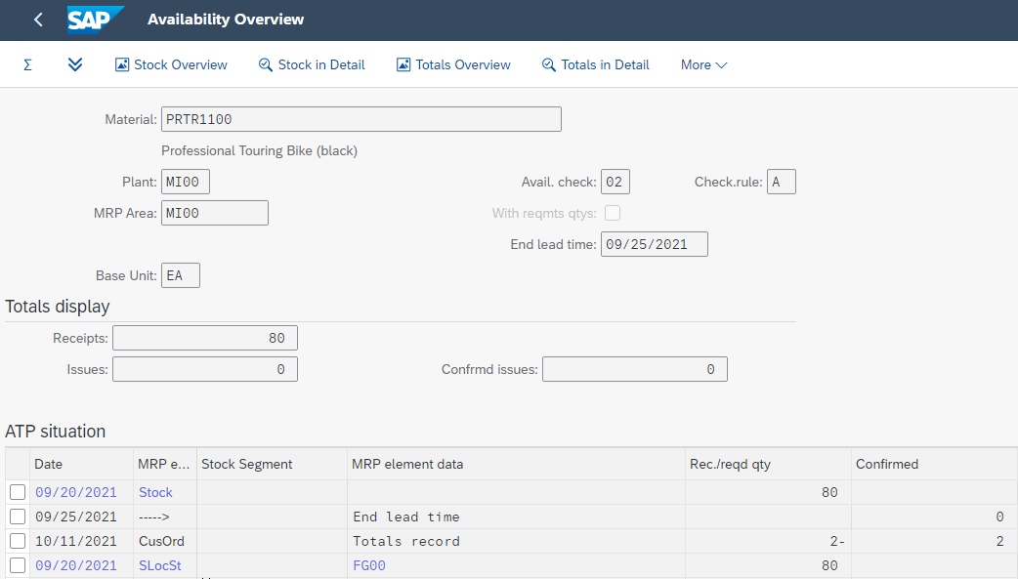
The Availability Overview screen shows that, in this case, there are actually 80 bikes in stock and the order you are displaying will use 2 of these.
Note Your ATP situation could show other inventory quantities.
Choose . If this button is not displayed, you will find the entry in the pull-down menu under: More ► Scope of check. The following screen will be displayed.
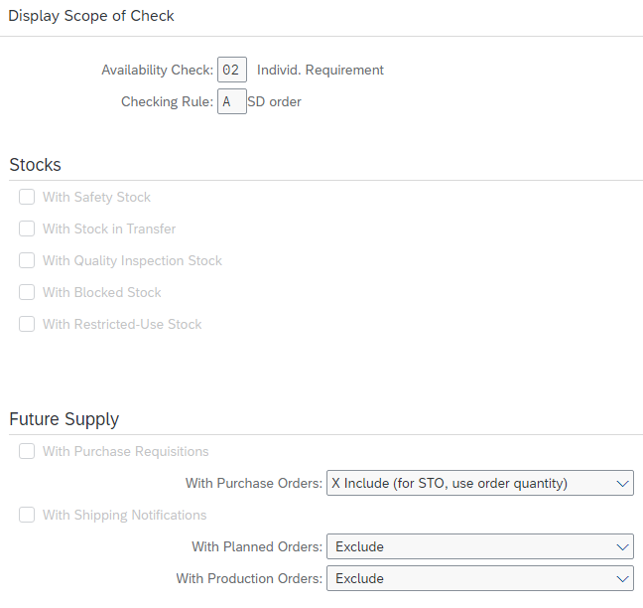
This screen displays the elements considered when performing the availability check. For example, With Purchase Orders is selected, which means that a purchase order will be considered as available stock from its receipt date onward. Click to close the pop-up window and click to return to the appointment order overview.
Select the Deluxe Touring Bike and click (Item Conditions) to view the conditions again. Note that the two discounts have been manually applied to this item.
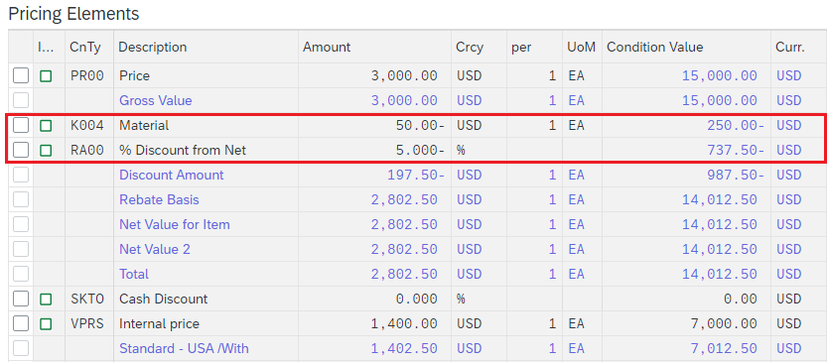
Click on to return to the SAP Fiori launchpad.

 | Step 9: Start Delivery Process
Task Start the delivery process.  Short Description Use the SAP Fiori Launchpad to start the delivery process.  Name (Position) Sergey Petrov (Warehouse Employee) |  | Time 5 min
To start the process that will fulfill The Bike Zone’s order, we need to create a delivery document. To do this, in the space Sales and Distribution and in the section Warehouse employee, use the Create Outbound Deliveries – From Sales Orders app. |  | Create Outbound Deliveries – From Sales Orders
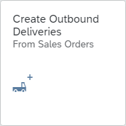
The app starts with a collapsed header area. Please expand it by clicking (Expand Header).
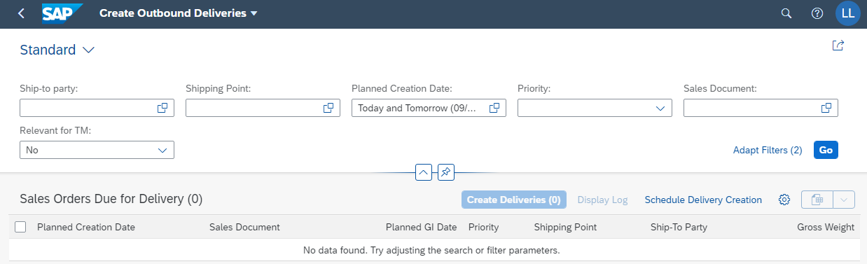
Note You trigger shipping activities by creating deliveries. The responsible organizational unit for creating deliveries is the shipping point. The shipping point can be a loading ramp, a mail depot, or a rail depot. It can also be, for example, a group of employees responsible (only) for organizing urgent deliveries. |  | Shipping Point
On the Create Outbound Deliveries screen, in the Ship-to party field please enter your business partner number (The Bike Zone). |  | Business Partner Number (Customer)
Note Alternatively, you can search for your GP number by selecting the input help icon in the Ship-to party field. A pop-up screen will open. As Full Name enter *###, and as City enter Orlando. Click to run the search. |  | *###  Orlando
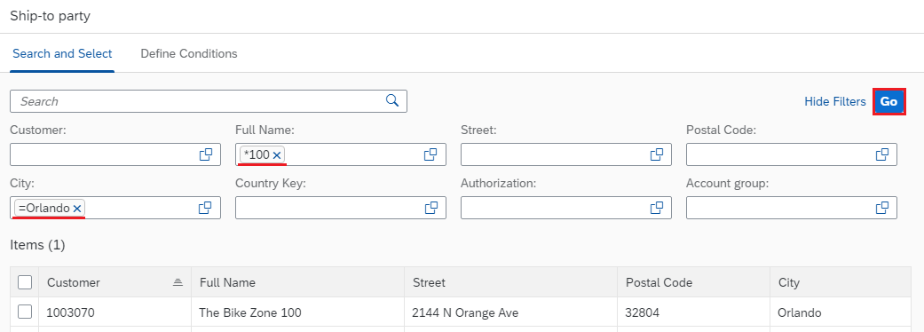
Select your customer and apply the entry to the initial screen by clicking .
In addition, as Shipping Point please enter MI00, and remove the Planned Creation Date. Click to run the search. The sales order will be displayed. |  | MI00
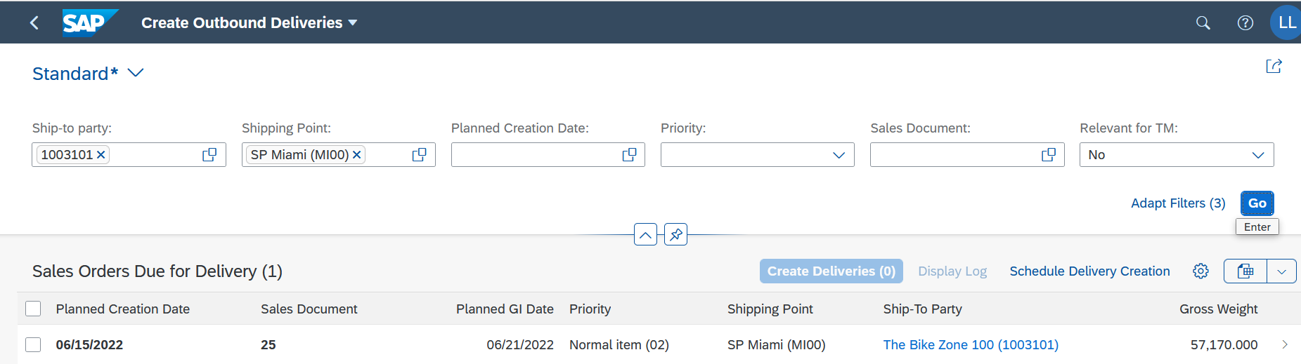
Select the sales document and choose the button . You will see that the sales document is no longer available. Additionally, you will receive a confirmation that your outbound delivery has been created.
Click on to return to the SAP Fiori launchpad.

 | Step 10: Track Sales Order
Task Track the processing status of the sales order.  Short Description Use the SAP Fiori Launchpad to track a sales order.  Name (Position) David Lopez (Sales Representative US East) |  | Time 5 min
To display and track a sales order, in the space Sales and Distribution and int the section Sales Representative, use the Track Sales Orders app again. |  | Track Sales Orders
You will see the standard view of the app. In the Search field, enter your number (###) and click to run the search process. |  | ###
Your order will be displayed in the result list. You can now see changes from the previous state. The Overall Fulfillment is now set to Partially processed and the Order Processing is completely processed.
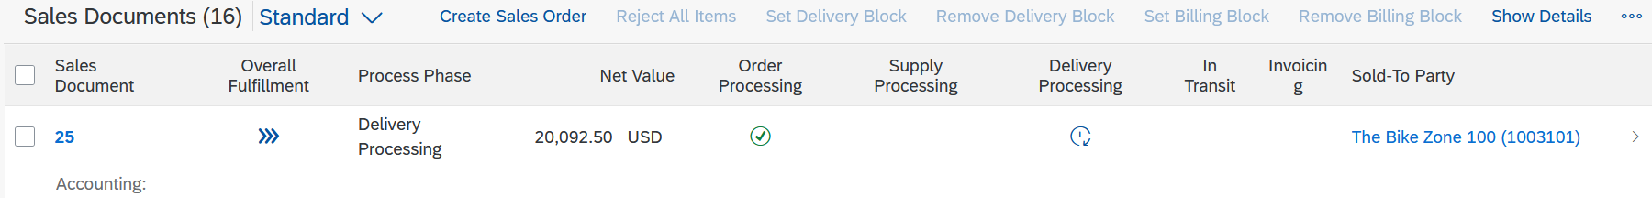
Please click on the line containing your sales order. You will be forwarded to the Track Sales Order Details screen, where you can see all the details of the order.
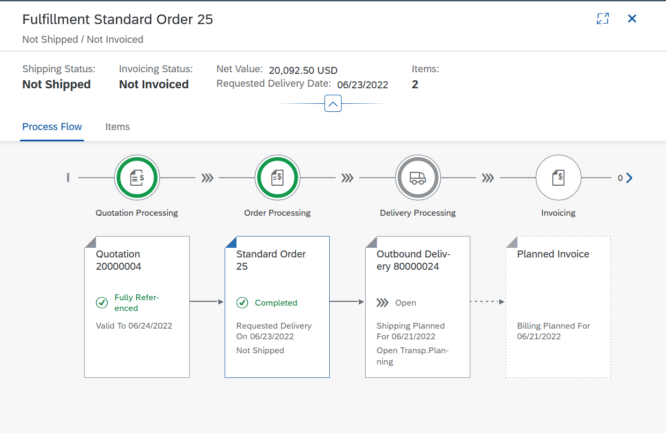
In the overview that opens, you can see the completed standard order and the delivery that is still “open”. In addition, billing has already been planned automatically by the system. In the header area, the shipping status (Not shipped; previously: Delivery Not Started) and the billing status (Not invoiced, previously: Not Relevant for Invoicing) have also changed.
Click on to return to the SAP Fiori launchpad.

 | Step 11: Pick Materials and Post Goods Issue
Task Pick materials on delivery note.  Short Description Use the SAP Fiori Launchpad to pick materials and to post a goods issue.  Name (Position) Sandeep Das (Warehouse Supervisor) |  | Time 5 min
Picking a material changes the outbound delivery document, while goods issue subsequently changes the ownership of the material from Global Bike to The Bike Zone. To do this, in the space Sales and Distribution and in the section Warehouse employee use the Manage Outbound Deliveries app. |  | Manage Outbound Deliveries
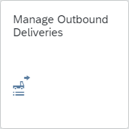
The app starts with a collapsed header area. Please expand it by clicking . In the Ship-to party field, please enter your business partner number. |  | Business Partner Number (Customer)
Note If you have forgotten your GP number, proceed as in the steps before.
In addition, as the Shipping Point enter MI00 and as Overall Status select All Open Deliveries. To run the search, click . Your outbound delivery is now displayed. |  | MI00  All Open Deliveries
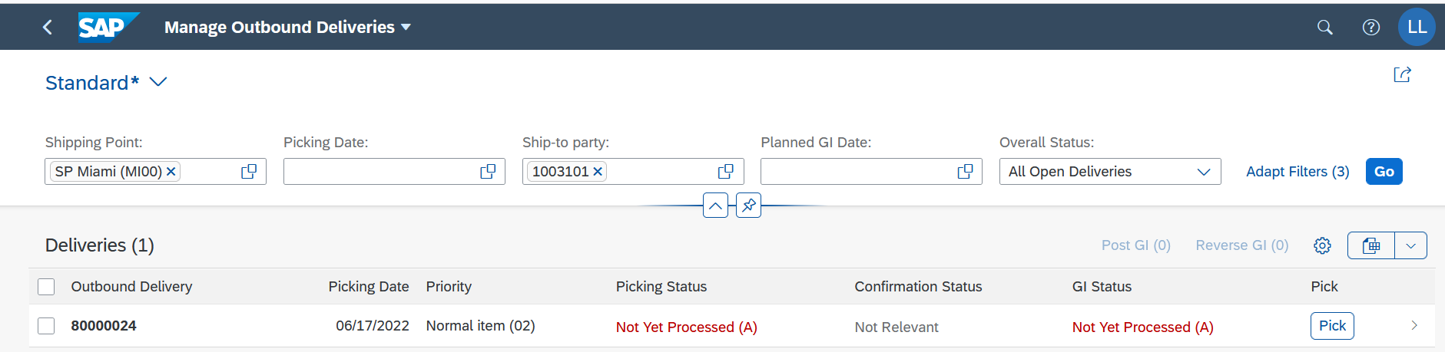
You can see that neither picking nor goods issue has been processed yet. Click on the line that contains your outbound delivery to get more details.
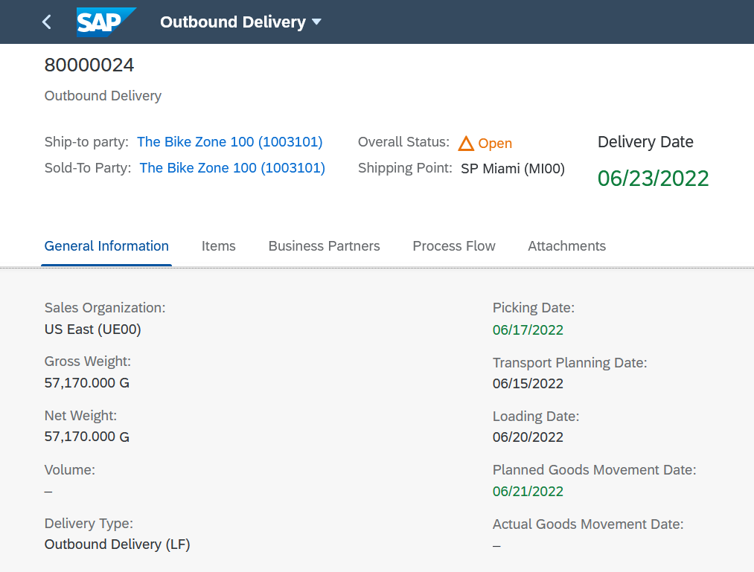
Please return to the Deliveries overview by clicking . Then, select to start picking. You will automatically be forwarded to the Pick Outbound Delivery app. Your outbound delivery is already preselected.
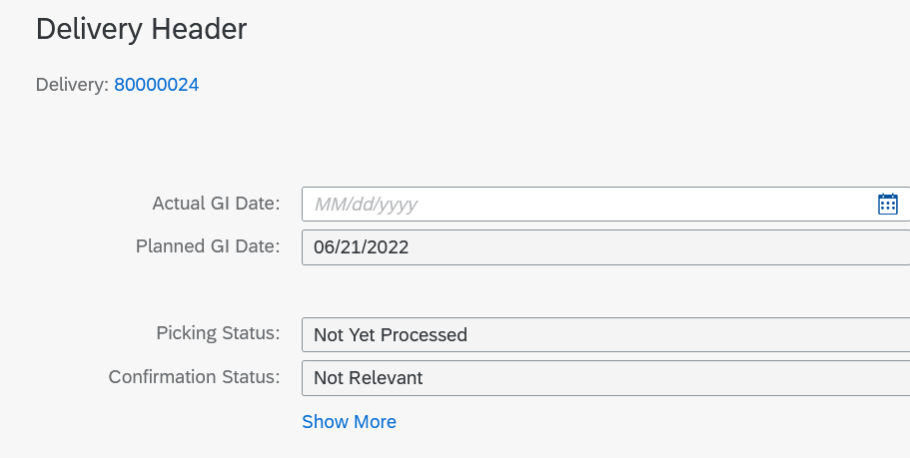
In the Delivery Items area, enter the appropriate quantities in the Picking Quantity fields: For your DXTR1### 5 and for your PRTR1### 2. |  | 5  2
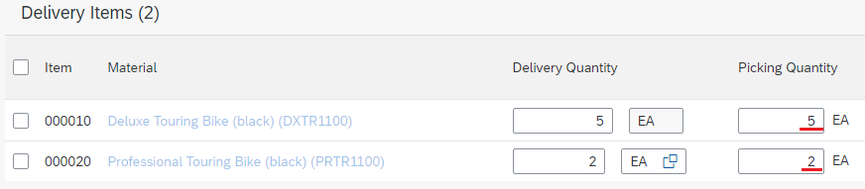
Picking is the process of preparing or staging goods for delivery to the customer, with particular attention to dates, quantity and quality. |  | Picking
At the end of the Deluxe Touring Bike row, select . In the Delivery Item 1 of 2 screen, in the Storage Location field, enter FG00 (Finished Goods). |  | FG00
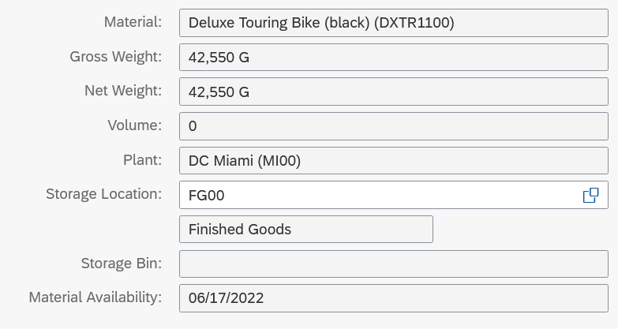
Click and repeat this step for the PRTR1### material. |  | PRTR###
Back in the Pick Outbound Delivery screen, please choose . You will receive a corresponding message from the system. In addition, the screen content changes. Picking is now complete and goods issue is ready.
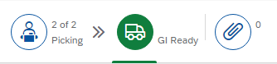
In the lower screen area, you can now click to post the goods issue. The screen content changes again. Both picking and goods issue are now complete.
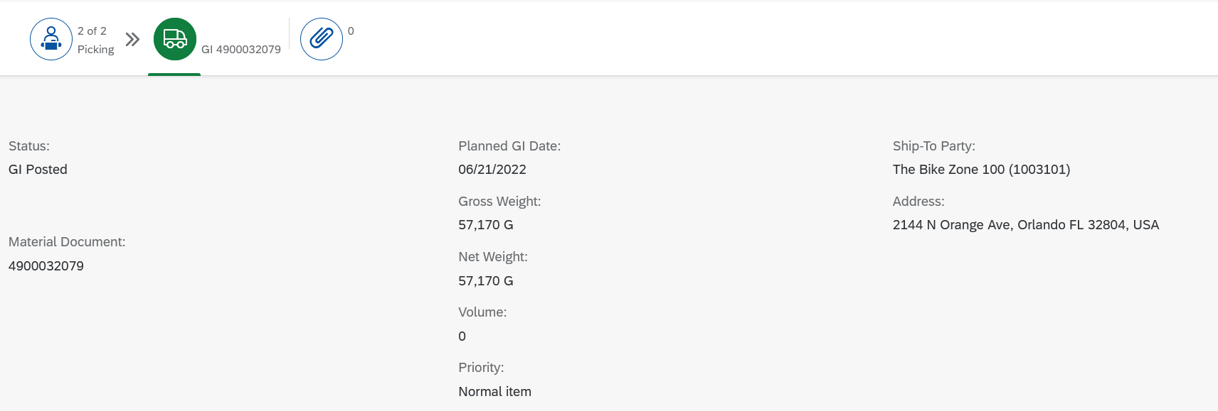
Click on to return to the SAP Fiori launchpad.

 | Step 12: Check Stock Status
Task Check the inventory once again.  Short Description Use the SAP Fiori Launchpad to check the stock status.  Name (Position) David Lopez (Sales Representative US East) |  | Time 5 min
The goods issue of the order has an impact of the inventory level of the bikes for Global Bike. To have a look at it, in the space Sales and Distribution and in the section Sales representative, use the Stock – Multiple Materials app. |  | Stock – Multiple Materials
You will see the default screen of the app. Due to the high amount of materials, it is not recommended to search without further restrictions. Therefore, in the Material Number field, please use the input help icon .
In the pop-up that opens, as Description enter *TOURING* and as Material type in your number (*###) again. |  | *TOURING*  *###
Click to run the search and to generate a result list of all “touring” bikes containing your number “###” in the material code. Select the Deluxe Touring Bike (black) and the Professional Touring Bike (black). To copy your selection to the initial screen, click on the button.
Back in the Stock – Multiple Materials overview, as Plant enter MI00 (Miami) and as Storage Location type in FG00 (Finished Goods). Click to display the corresponding stock levels again. |  | MI00  FG00
This report shows the stock levels for the plant in Miami. Scroll to the right to see the unrestricted stock. The inventory was reduced by the quantity for which the goods issue was posted.
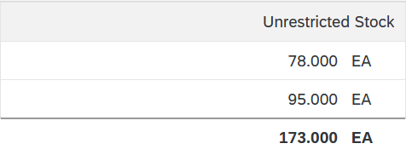
Click on to return to the SAP Fiori launchpad.

 | Step 13: Create billing document for Customer
Task Create a billing document for a customer.  Short Description Use the SAP Fiori Launchpad to create a customer billing document.  Name (Position) Stephanie Bernard (AR Accountant) |  | Time 10 min
With the delivery complete, the customer can be invoiced. To do this, in the space Sales and Distribution and in the section AR Accountant, use the Create Billing Documents app. |  | Create Billing Documents
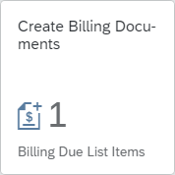
In the Create Billing Documents screen, all Billing Due List Items are automatically listed. For a better overview, the listing should be filtered. To do this, in the Sold-to party field, enter your business partner number. |  | Business Partner Number (Customer)
Note If you have forgotten your GP number, proceed as in the steps before.
Apply the new filter. Therefore, click on to restrict the result list. Your sales document will be the only one displayed.
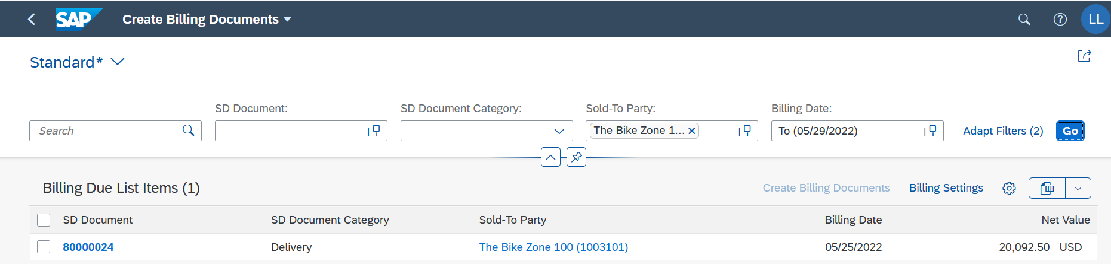
Select your sales document and choose . The system prepares the customer invoice: The date and sold-to party are copied from the previous selection.
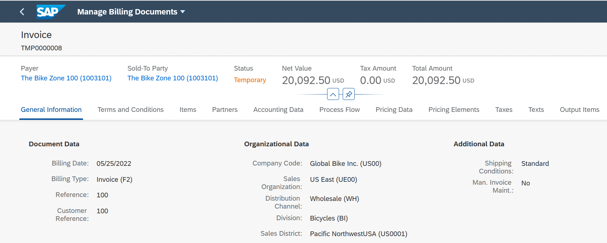
Choose the Process Flow tab. There you can track the steps taken in advance that are relevant for the customer invoice. |  | Process Flow
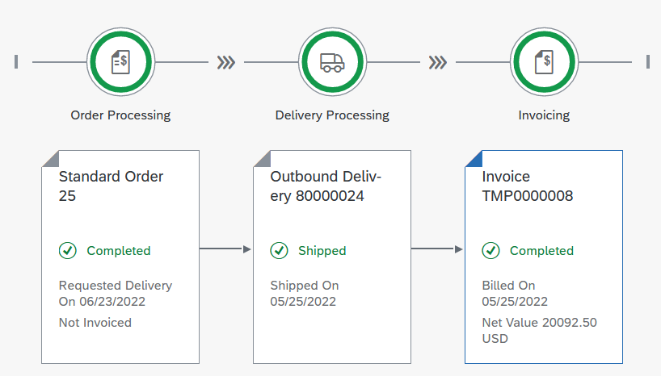
Continue to the Pricing Elements tab. As a billing clerk, you can view the discounts granted in the quotation creation and how the total price is thus composed. |  | Pricing Elements
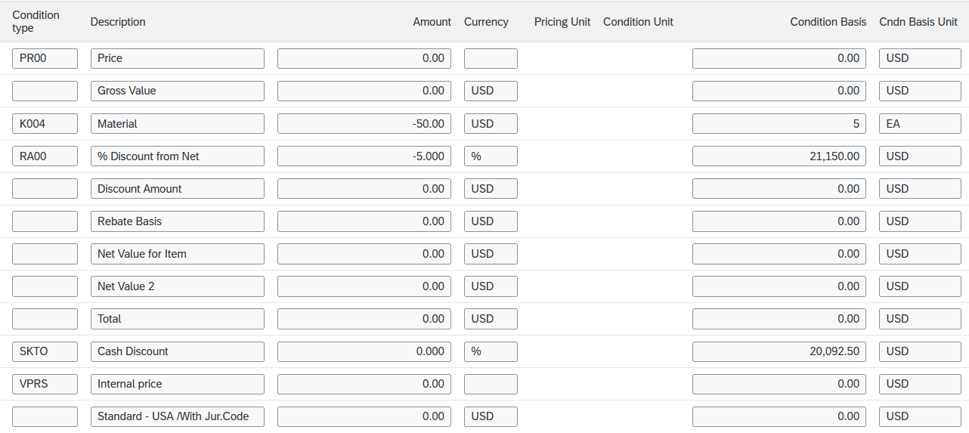
To save the new customer invoice, select .
Click on to return to the SAP Fiori launchpad.

 | Step 14: Display Billing Document and Post Customer Invoice
Task Display a billing document and a customer invoice.  Short Description Use the SAP Fiori Launchpad to display a billing document/customer invoice.  Name (Position) Stephanie Bernard (AR Accountant) |  | Time 5 min
Now that the billing document has been created, it needs to be posted. Therefore, in the space Sales and Distribution and in the section AR Accountant, use the Manage Billing Documents app. |  | Manage Billing Documents
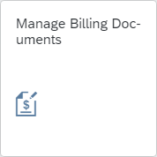
On the Manage Billing Documents screen, in the Sold-to party field, please enter your business partner number. |  | Business Partner Number (Customer)
Note Alternatively, in the Sold-to party field, click the input help icon and search for your business partner using your number (###) as in the previous step. |  | ###
Select to display your invoice.
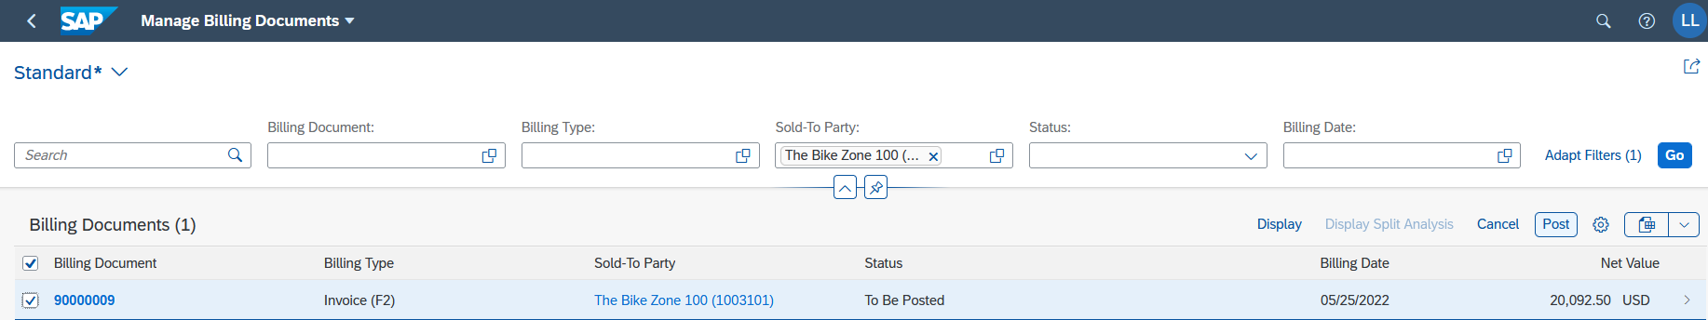
Select your entry and choose . This will send the invoice to the customer.
Click on to return to the SAP Fiori launchpad.

 | Step 15: Post Receipt of Customer Payment
Task Post a customer payment receipt.  Short Description Use the SAP Fiori Launchpad to post a customer payment receipt.  Name (Position) Stephanie Bernard(AR Accountant) |  | Time 10 min
After The Bike Zone mails its payment, it needs to be recorded. To do this, in the space Sales and Distribution and in the section AR Accountant use the Post Incoming Payments app. |  | Post Incoming Payments
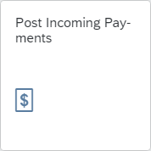
You will be directed to the following screen.
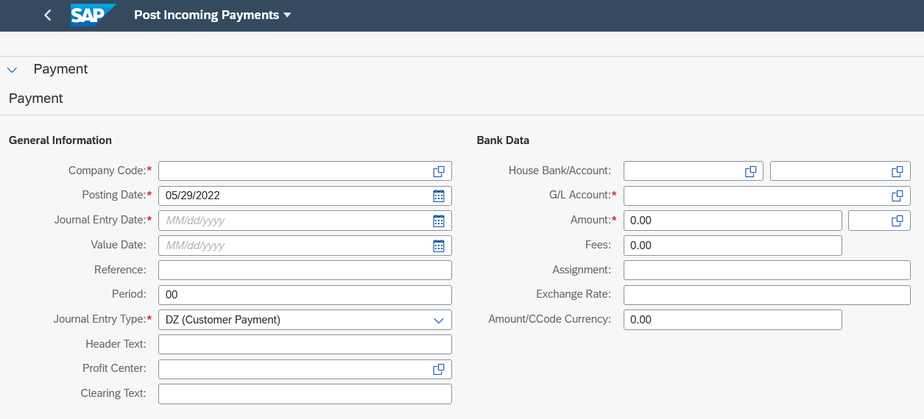
In the General Information area, as Company Code enter US00 (Global Bike Inc.). In the fields Posting Date and Journal Entry Date, use (Open Picker) to enter the current date. Also, in the Period field, select the current period (for example, 09 for September). As the Journal Entry Type make sure that DZ (Customer Payment) is selected. |  | US00  Current Date  Current Period  DZ
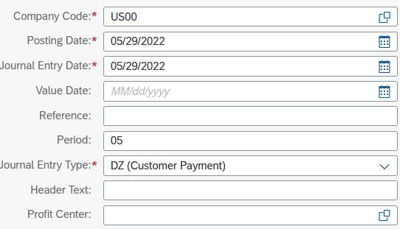
In the Bank Data area, as G/L account select 1810000 (Bank 1). Please also add the amount 20,092.50 USD. In the Open Item Selection area, as the Account Type select Customer, and add in the field directly next to it your business partner number. Compare your entries with the following screenshots. |  | 1810000  20,092.50 USD  Customer  Business Partner Number (Customer)
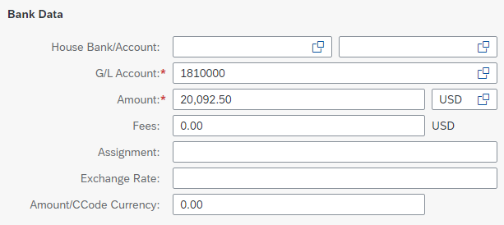
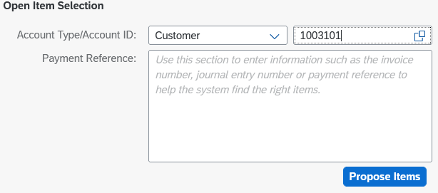
Click on . In the upper part of the screen, you can see that the balance has changed to . This is due to the open customer invoice. In the Open Items area, the posting document from the previous steps will also be proposed to you.
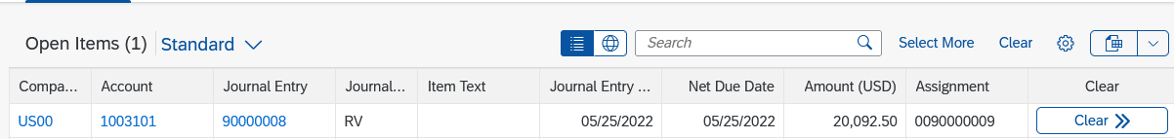
Select in the line of the posting document. The open items are added to the Items to be Cleared with the recorded incoming payment.
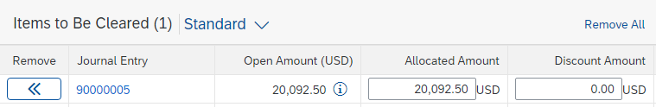
Since the incoming payment covers the full amount, the balance is cleared again (). Click to save the incoming payment. The system will automatically assign a number to it.
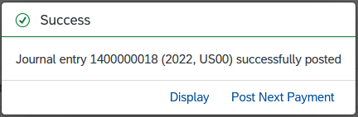 |  | Journal Entry  Incoming Payment:  ___________________
Choose to additionally display the posting document. In the Manage Journal Entries screen, you can view individual posting items.
Click on to return to the SAP Fiori launchpad.

 | Step 16: Review Document Flow
Task Review the document flow.  Short Description Use the SAP Fiori Launchpad to review the document flow.  Name (Position) David Lopez (Sales Representative US East) |  | Time 5 min
The document flow tool links all documents that were used in The Bike Zone’s sales order. Again, there are many ways to access the document flow tool. One way is to start by displaying the sales order document. |  | Document Flow
To display and track a sales order, in the space Sales and Distribution and in the section Sales representative use the Track Sales Orders app again. |  | Track Sales Orders
You will see the standard view of the app. In the Search field, enter your number (###) and click to run the search process. |  | ###
Your order will be displayed in the result list. Again, you can see changes from the previous state. The Overall Fulfillment is now set to Completely Processed.
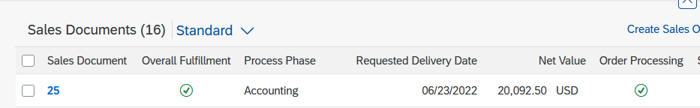
Please click on the line containing your sales order. You will be forwarded to the Track Sales Order Details screen, where you can see all the details of the order. For example, in the Fulfillment area the document flow for the sales order is displayed. All related documents are completely generated and recorded.
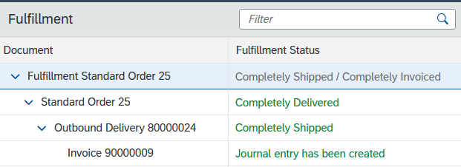
Depending on which document is selected, the content of the right screen changes. Thus, information on the delivery or the invoice can be viewed directly. Choosing the Fulfillment Standard Order, the steps from the quotation to the journal entry are displayed as a process flow. The respective documents can also be called up from here.
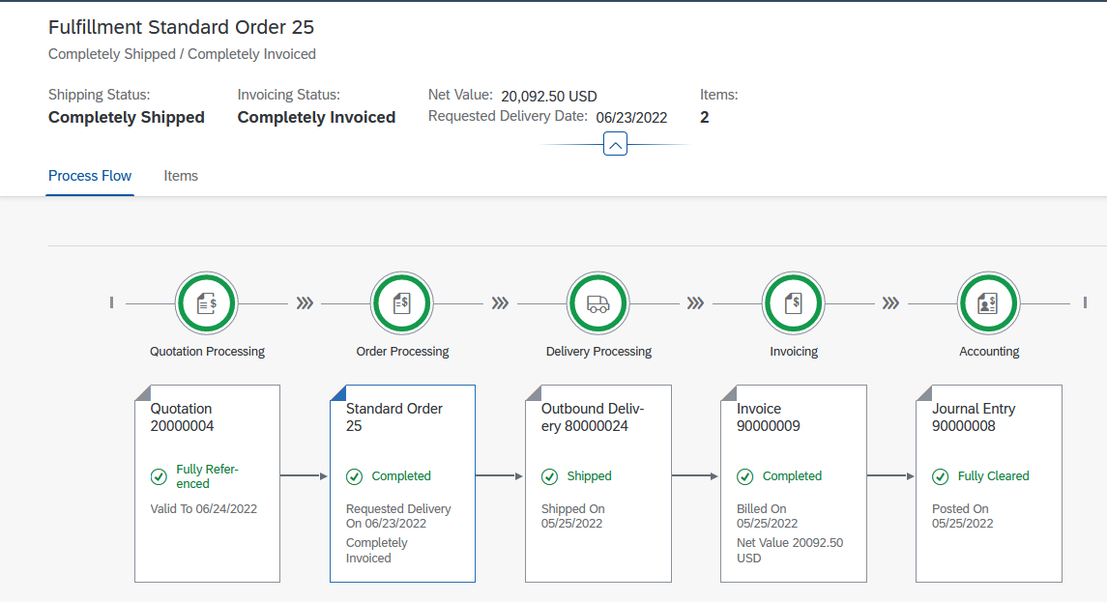
As you can see, in the header area, both the shipping status (Completely Shipped) and the invoicing status (Completely Invoiced) have changed again. Finally, on the Process Flow tab, select the journal entry to open the context menu. Click Manage Journal Entries to access the corresponding app. |  | Process Flow  Manage Journal Entries
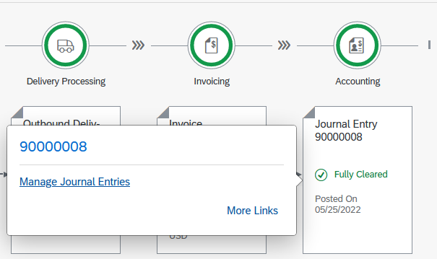
You can see the line items in the header data of the journal entry. However, choose the Related Documents tab. Then expand the document flow completely. |  | Related Documents
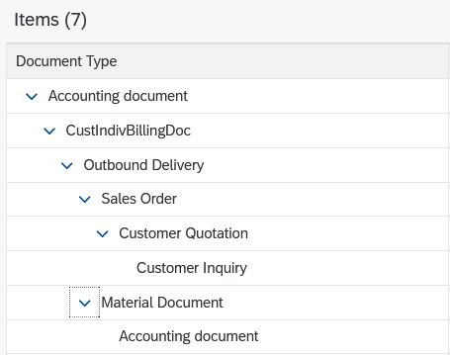
Except for the incoming payment, you can see all documents generated for the sales order. This additionally includes the customer inquiry, as well as the material document including the accounting document of the delivery.
Click the document number of the sales order to open the context menu and choose . In the pop-up that opens, select the Display Document Flow app.
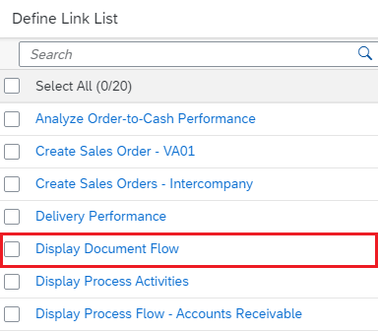
In the following screen you can see both the operational document flow and the G/L document flow.
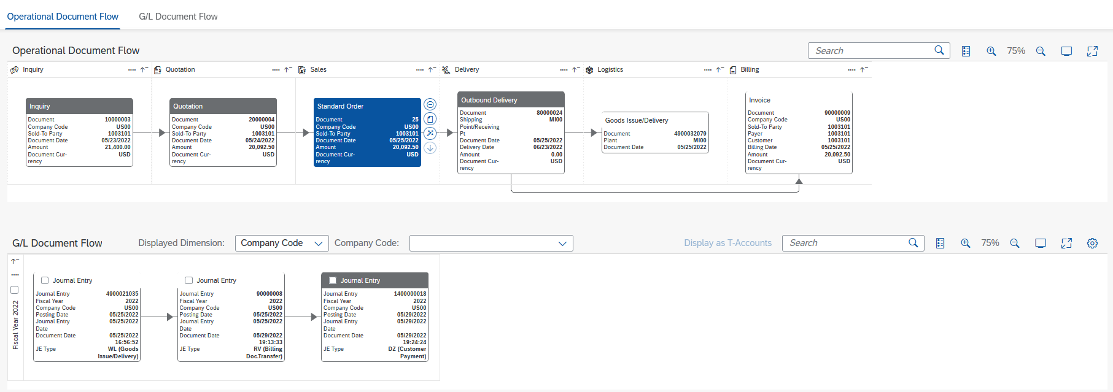
Click on to return to the SAP Fiori launchpad.

 | SD Challenge
Learning Objective Understand and perform an integrated order-to-cash-process. |  | Time 75 min
Motivation Having successfully completed the case study Sales and Distribution, you should be able to perform the following task independently.
Scenario One of your existing customers has opened an independent offshoot Alster Adventures in Hamburg and would like to benefit from your new promotion with this, in which there is a free off-road helmet for each mountain bike ordered. Individual items can be marked as a free item (AGNN) in the item details of the appointment order. Make sure that off-road helmets belong to a different division. Create a new customer Alster Adventures using Alster Cycling (customer 14000) as a template. Have your new customer supplied from the factory in Hamburg (HH00) via the sales organization Germany North (DN00). Remember that the Euro is the common means of payment in Europe. Companies in Germany are subject to tax. Also expand Alster Adventures so that orders can be placed for accessories and across divisions.
Then, as Alster Adventures, order five mountain bikes for men and five mountain bikes for women. As a long-term customer, Alster Adventures will receive a discount of $50 per bike on the order and 3% of the net price on the entire purchase.
Task Information Perform a complete order-to-cash-process including the incoming payment of your customer. Since this task is based on the case study Sales and Distribution, you are allowed to use it for support. It is however recommended to solve this advanced task without support to test the newly gained knowledge.

